同济大学

**《数据库技术与应用》**

**项目设计报告**

**项目设计报告题目：**

地震监测软件项目设计报告

**小组成员姓名 ： 高程展 1751173**

**任泽琦 1750858**

**__ 利剑韬 1751178**

**年级：** 2 **专业：** 土木工程

**指导教师：** 袁科萍

**日期：** 2019 **年** 6 **月** 16 **日**

项目设计报告内容

# 项目设计的目的和意义

地震是对人类生活影响最大的地质运动之一，同样也给人类的生命财产安全造成了巨大的损失。研究表明，如果及时传播最新的地震信息进行预警，提供最有效的防灾避难路线对人员进行疏散工作，可以有效地降低人员死亡和财产损失。而且，地震信息对于地质研究和工程建设也有重大意义。本软件可以给客户提供最新的地震信息，并且根据客户IP定位地点给出最方便的防灾避难路线。不仅如此，软件中庞大的数据库囊括了许多地震的地点、震级、深度以及烈度分析等，图文并茂，为研究人员进行地质研究和工程单位进行地质勘查都提供了极大的便捷。

# 项目主要功能描述

查询

本软件提供了多样的查询手段。这其中包括在首页直接快捷查询，显示最近30天地震的相关信息，也可以按照时间和震级对地震进行条件查询，还可以更细致地定位到准确的日期和月份查询地震信息。丰富的条件查询，可以最大程度上满足客户对于地震信息的需要。

统计

本软件提供了地震信息的分析统计功能。在统计栏目当中，我们可以对一定时间范围内的地震进行频度和深度的统计，以此分析出地震在这段时间的发展趋势，对工程地质的研究有一定的帮助。

避难

本软件提供了应急避难路线设计功能。在首页我们可以通过IP地址定位客户位置，如果周围发生地震，软件可以自动为客户定位到最近的应急避难场所，为客户逃生规划路线。这样的避难功能对于地震期间人员逃生疏散有至关重要的作用。

科普

本软件提供了地震信息的科普功能。在地震专题栏目中，我们可以看到一些地震的精确信息，除了经纬度和震级深度这些基本信息之外，还有地震构造以及烈度等专业信息，并且图文并茂，让客户更清晰地了解相关地震的信息，便于开展研究学习。

# 三．数据库设计

1．数据需求分析

### **1.1地震**

用户需要了解地震的基本信息，如：地震位置（行政区）、震源深度、地震坐标、震级大小；对于特别的典型地震，用户同样需要进一步了解地震的其他属性，如烈度大小、震源机制、发震构造、波形图记录、余震精定位、震中位置等等。

### **1.2应急避难场所**

当用户周围出现破坏性地震时，需要为用户提供应急避难场所的地理位置及相关信息。

2．概念模式设计（E-R图设计）

### 实体定义

地震：时间，地区，震源深度，震级大小，经度，纬度；

典型地震：时间，地区，震源机制，发震构造，烈度分布，波形图记录，余震精定位，震中位置；

国家：国家名；

省/自治区：省名；

市/自治乡：市名；

应急避难场所：场所名称，所属区县，建设类别，经度，纬度，总占面积，有效使用面积，避难人数，建设类型；

### 联系描述

一场地震有时间，地区，震源深度，震级大小，经度，纬度六个特征属性，由时间和地区作为唯一标识；典型地震是地震的一个子类，除了超类地震的特征属性，还有震源机制，发震构造，烈度分布，波形图记录，余震精定位，震中位置等信息。每个国家可以发生多次地震，地震也可以发生在不同的国家，所以地震和国家间是多对多的关系。每个多家有若干省份，但是每个省隶属于一个国家，所以国家和省是一对多的关系。同理，每个省份有若干个市，但每个市隶属于一个省份，所以省份和市是一对多的关系。国家有一个国家名，并由国家名作为唯一标识。省份有一个省份名，并由省份名作为唯一标识。市有一市名，并由时作为唯一标识。

### E-R图





3．逻辑模式设计（转换为关系模式和规范化处理）

### 关系模式

地震（时间，地区，震源深度，震级大小，经度，纬度）

典型地震（时间，地区，震源机制，发震构造，烈度分布，波形图记录，余震精定位，震中位置）

省/自治州（id，省/自治州名）

市/自治乡（id，市/自治乡名）

应急避难场所：（场所名称，所属区县，建设类别，经度，纬度，总占面积，有效使用面积，避难人数，建设类型）

### 规范化处理

地震、典型地震、省、市和应急避难场所的数据表中所有属性都是不可分割的属性，所以都满足一范式。

地震数据表中震源深度、震级大小，经度，纬度不能互相决定，即任意一个主键都不能单独决定其他非主属性，所以不存在非主属性部分依赖于主键，满足二范式，每个非主属性也都没有传递函数依赖关系，所以满足三范式。

同理可分析典型地震的数据表，也满足三范式。

省、市和应急避难场所都是单个属性作为主键，所以不可能存在部分函数依赖，所以满足二范式；而其中省、市的数据表只有一个非主属性，所以不可能存在传递因子，所以也满足三范式。而应急避难场所的数据表中的非主属性不存在互相决定的关系，所以也没有传递函数依赖，所以也满足三范式。

4．数据库实施

### 地震数据表earthquake_data

create table earthquake_data

(

F1 varchar(255) not null check (F1 like '%[0-2][0-9][0-9][0-9]-[0-9][0-9]-[0-9][0-9]%[0-9]:[0-9][0-9]:[0-9][0-9]%'

or F1 like '%[0-2][0-9][0-9][0-9]-[0-9]-[0-9][0-9]%[0-9]:[0-9][0-9]:[0-9][0-9]%'

or F1 like '%[0-2][0-9][0-9][0-9]-[0-9][0-9]-[0-9]%[0-9]:[0-9][0-9]:[0-9][0-9]%'

or F1 like '%[0-2][0-9][0-9][0-9]-[0-9]-[0-9]%[0-9]:[0-9][0-9]:[0-9][0-9]%'),

F2 float not null check (F2 between 0 and 20),

F3 float not null check(F3 between -90 and 90),

F4 float not null check (F4 between -180 and 180),

F5 float not null check (F5 between 0 and 6400),

F6 varchar(255) not null,

primary key(F1,F6)

)

### 用户密码表Account

create table account

(

id varchar(20) not null primary key,

password varchar(30) not null,

)

### 地震专题的典型地震信息表information

create table information

(

location varchar(50) not null,

etime datetime not null,

long varchar(10),

lati varchar(10),

magni float check(magni between 0 and 20),

depth varchar(10) check (depth like '%[0-9]千米' or depth like '[0-9][0-9]千米'or depth like '[0-9][0-9][0-9]千米'),

pic1 varchar(30) not null check(pic1 like '%[0-9]-[0-9].jpg'),

pic2 varchar(30) not null check(pic2 like '%[0-9]-[0-9].jpg'),

pic3 varchar(30) not null check(pic3 like '%[0-9]-[0-9].jpg'),

name1 varchar(30) not null check (name1 in ('震源机制','发震构造','烈度分布','波形图记录','余震精定位','震中位置')),

name2 varchar(30) not null check (name2 in ('震源机制','发震构造','烈度分布','波形图记录','余震精定位','震中位置')),

name3 varchar(30) not null check (name3 in ('震源机制','发震构造','烈度分布','波形图记录','余震精定位','震中位置')),

primary key(location,etime)

)

### 应急避难场所表emergency_place

create table emergency_place

( 场所名称 varchar(50) not null primary key,

所属区县 varchar(50) check(所属区县 like '%闸北%'or 所属区县 like '%黄浦%'or 所属区县 like '%徐汇%'

or 所属区县 like '%长宁%'or 所属区县 like '%静安%'or 所属区县 like '%普陀%' or 所属区县 like '%黄埔%'

or 所属区县 like '%虹口%'or 所属区县 like '%杨浦%'or 所属区县 like '%浦东新%'

or 所属区县 like '%闵行%'or 所属区县 like '%宝山%'or 所属区县 like '%嘉定%'

or 所属区县 like '%金山%'or 所属区县 like '%松江%'or 所属区县 like '%青浦%'

or 所属区县 like '%奉贤%'or 所属区县 like '%崇明%'),

建设类别 varchar(50) not null check(建设类别 like '%类%'),

总占地面积 float check(总占地面积 between 0 and 10000),

有效使用面积 float check(有效使用面积 between 0 and 10000),

避难人数 float check(避难人数 between 0 and 100),

建设类型 varchar(50) check(建设类型 like '%场所与场地%'or 建设类型 like '%场所%'or 建设类型 like '%场地%'),

lab float not null check (lab between -90 and 90),

lng float not null check (lng between -180 and 180),

)

### 行政区划表city、promary

create table promary

(

proID int primary key,

proName varchar(50) not null

)

insert into promary values(1,'北京')

insert into promary values(2,'天津')

insert into promary values(3,'上海')

insert into promary values(4,'重庆')

insert into promary values(5,'河北')

insert into promary values(6,'山西')

insert into promary values(7,'台湾')

insert into promary values(8,'辽宁')

insert into promary values(9,'吉林')

insert into promary values(10,'黑龙江')

insert into promary values(11,'江苏')

insert into promary values(12,'浙江')

insert into promary values(13,'安徽')

insert into promary values(14,'福建')

insert into promary values(15,'江西')

insert into promary values(16,'山东')

insert into promary values(17,'河南')

insert into promary values(18,'湖北')

insert into promary values(19,'湖南')

insert into promary values(20,'广东')

insert into promary values(21,'甘肃')

insert into promary values(22,'四川')

--insert into promary values(23,'山东省')

insert into promary values(24,'贵州')

insert into promary values(25,'海南')

insert into promary values(26,'云南')

insert into promary values(27,'青海')

insert into promary values(28,'陕西')

insert into promary values(29,'广西')

insert into promary values(30,'西藏')

insert into promary values(31,'宁夏')

insert into promary values(32,'新疆')

insert into promary values(33,'内蒙古')

insert into promary values(34,'澳门')

insert into promary values(35,'香港')

create table city

(

cityID int not null,

cityName varchar(50) primary key,

proID int foreign key references promary(proID)

)

insert into city values(1,'北京市',1)

insert into city values(1,'天津市',2)

insert into city values(1,'上海市',3)

insert into city values(1,'重庆市',4)

--5河北省(2005年辖：11个地级市，36个市辖区、22个县级市、108个县、6个自治县)

insert into city values(1,'石家庄市',5)

insert into city values(2,'唐山市',5)

insert into city values(3,'秦皇岛市',5)

insert into city values(4,'邯郸市',5)

insert into city values(5,'邢台市',5)

insert into city values(6,'保定市',5)

insert into city values(7,'张家口市',5)

insert into city values(8,'承德市',5)

insert into city values(9,'沧州市',5)

insert into city values(10,'廊坊市',5)

insert into city values(11,'衡水市',5)

--6山西省11个城市

insert into city values(1,'太原市',6)

insert into city values(2,'大同市',6)

insert into city values(3,'阳泉市',6)

insert into city values(4,'长治市',6)

insert into city values(5,'晋城市',6)

insert into city values(6,'朔州市',6)

insert into city values(7,'晋中市',6)

insert into city values(8,'运城市',6)

insert into city values(9,'忻州市',6)

insert into city values(10,'临汾市',6)

insert into city values(11,'吕梁市',6)

--7台湾省(台湾本岛和澎湖共设7市、16县，其中台北市和高雄市为“院辖市”，直属“行政院”，其余属台湾省；市下设区，县下设市（县辖市）、镇、乡，合称区市镇乡。)

insert into city values(1,'台北市',7)

insert into city values(2,'高雄市',7)

insert into city values(3,'基隆市',7)

insert into city values(4,'台中市',7)

insert into city values(5,'台南市',7)

insert into city values(6,'新竹市',7)

insert into city values(7,'嘉义市',7)

insert into city values(8,'台北县',7)

insert into city values(9,'宜兰县',7)

insert into city values(10,'桃园县',7)

insert into city values(11,'新竹县',7)

insert into city values(12,'苗栗县',7)

insert into city values(13,'台中县',7)

insert into city values(14,'彰化县',7)

insert into city values(15,'南投县',7)

insert into city values(16,'云林县',7)

insert into city values(17,'嘉义县',7)

insert into city values(18,'台南县',7)

insert into city values(19,'高雄县',7)

insert into city values(20,'屏东县',7)

insert into city values(21,'澎湖县',7)

insert into city values(22,'台东县',7)

insert into city values(23,'花莲县',7)

--8辽宁省(2006年，辖：14个地级市；56个市辖区、17个县级市、19个县、8个自治县。)

insert into city values(1,'沈阳市',8)

insert into city values(2,'大连市',8)

insert into city values(3,'鞍山市',8)

insert into city values(4,'抚顺市',8)

insert into city values(5,'本溪市',8)

insert into city values(6,'丹东市',8)

insert into city values(7,'锦州市',8)

insert into city values(8,'营口市',8)

insert into city values(9,'阜新市',8)

insert into city values(10,'辽阳市',8)

insert into city values(11,'盘锦市',8)

insert into city values(12,'铁岭市',8)

insert into city values(13,'朝阳市',8)

insert into city values(14,'葫芦岛市',8)

--9吉林省(2006年，辖：8个地级市、1个自治州；20个市辖区、20个县级市、17个县、3个自治县。)

insert into city values(1,'长春市',9)

insert into city values(2,'吉林市',9)

insert into city values(3,'四平市',9)

insert into city values(4,'辽源市',9)

insert into city values(5,'通化市',9)

insert into city values(6,'白山市',9)

insert into city values(7,'松原市',9)

insert into city values(8,'白城市',9)

insert into city values(9,'延边朝鲜族自治州',9)

--10黑龙江省(2006年，辖：12地级市、1地区；64市辖区、18县级市、45县、1自治县)

insert into city values(1,'哈尔滨市',10)

insert into city values(2,'齐齐哈尔市',10)

insert into city values(3,'鹤 岗 市',10)

insert into city values(4,'双鸭山市',10)

insert into city values(5,'鸡 西 市',10)

insert into city values(6,'大 庆 市',10)

insert into city values(7,'伊 春 市',10)

insert into city values(8,'牡丹江市',10)

insert into city values(9,'佳木斯市',10)

insert into city values(10,'七台河市',10)

insert into city values(11,'黑 河 市',10)

insert into city values(12,'绥 化 市',10)

insert into city values(13,'大兴安岭地区',10)

--11江苏省(2005年辖：13个地级市；54个市辖区、27个县级市、25个县)

insert into city values(1,'南京市',11)

insert into city values(2,'无锡市',11)

insert into city values(3,'徐州市',11)

insert into city values(4,'常州市',11)

insert into city values(5,'苏州市',11)

insert into city values(6,'南通市',11)

insert into city values(7,'连云港市',11)

insert into city values(8,'淮安市',11)

insert into city values(9,'盐城市',11)

insert into city values(10,'扬州市',11)

insert into city values(11,'镇江市',11)

insert into city values(12,'泰州市',11)

insert into city values(13,'宿迁市',11)

--12浙江省(2006年，辖：11个地级市；32个市辖区、22个县级市、35个县、1个自治县。)

insert into city values(1,'杭州市',12)

insert into city values(2,'宁波市',12)

insert into city values(3,'温州市',12)

insert into city values(4,'嘉兴市',12)

insert into city values(5,'湖州市',12)

insert into city values(6,'绍兴市',12)

insert into city values(7,'金华市',12)

insert into city values(8,'衢州市',12)

insert into city values(9,'舟山市',12)

insert into city values(10,'台州市',12)

insert into city values(11,'丽水市',12)

--13安徽省(2005年辖：17个地级市；44个市辖区、5县个级市、56个县。)

insert into city values(1,'合肥市',13)

insert into city values(2,'芜湖市',13)

insert into city values(3,'蚌埠市',13)

insert into city values(4,'淮南市',13)

insert into city values(5,'马鞍山市',13)

insert into city values(6,'淮北市',13)

insert into city values(7,'铜陵市',13)

insert into city values(8,'安庆市',13)

insert into city values(9,'黄山市',13)

insert into city values(10,'滁州市',13)

insert into city values(11,'阜阳市',13)

insert into city values(12,'宿州市',13)

insert into city values(13,'巢湖市',13)

insert into city values(14,'六安市',13)

insert into city values(15,'亳州市',13)

insert into city values(16,'池州市',13)

insert into city values(17,'宣城市',13)

--14福建省(2006年辖：9个地级市；26个市辖区、14个县级市、45个县。)

insert into city values(1,'福州市',14)

insert into city values(2,'厦门市',14)

insert into city values(3,'莆田市',14)

insert into city values(4,'三明市',14)

insert into city values(5,'泉州市',14)

insert into city values(6,'漳州市',14)

insert into city values(7,'南平市',14)

insert into city values(8,'龙岩市',14)

insert into city values(9,'宁德市',14)

--15江西省(2006年全省辖：11个地级市；19个市辖区、10个县级市、70个县。)

insert into city values(1,'南昌市',15)

insert into city values(2,'景德镇市',15)

insert into city values(3,'萍乡市',15)

insert into city values(4,'九江市',15)

insert into city values(5,'新余市',15)

insert into city values(6,'鹰潭市',15)

insert into city values(7,'赣州市',15)

insert into city values(8,'吉安市',15)

insert into city values(9,'宜春市',15)

insert into city values(10,'抚州市',15)

insert into city values(11,'上饶市',15)

--16山东省(2005年，辖：17个地级市；49个市辖区、31个县级市、60个县。)

insert into city values(1,'济南市',16)

insert into city values(2,'青岛市',16)

insert into city values(3,'淄博市',16)

insert into city values(4,'枣庄市',16)

insert into city values(5,'东营市',16)

insert into city values(6,'烟台市',16)

insert into city values(7,'潍坊市',16)

insert into city values(8,'济宁市',16)

insert into city values(9,'泰安市',16)

insert into city values(10,'威海市',16)

insert into city values(11,'日照市',16)

insert into city values(12,'莱芜市',16)

insert into city values(13,'临沂市',16)

insert into city values(14,'德州市',16)

insert into city values(15,'聊城市',16)

insert into city values(16,'滨州市',16)

insert into city values(17,'菏泽市',16)

--17河南省（2005年辖：17个地级市；50个市辖区、21个县级市、88个县。）

insert into city values(1,'郑州市',17)

insert into city values(2,'开封市',17)

insert into city values(3,'洛阳市',17)

insert into city values(4,'平顶山市',17)

insert into city values(5,'安阳市',17)

insert into city values(6,'鹤壁市',17)

insert into city values(7,'新乡市',17)

insert into city values(8,'焦作市',17)

insert into city values(9,'濮阳市',17)

insert into city values(10,'许昌市',17)

insert into city values(11,'漯河市',17)

insert into city values(12,'三门峡市',17)

insert into city values(13,'南阳市',17)

insert into city values(14,'商丘市',17)

insert into city values(15,'信阳市',17)

insert into city values(16,'周口市',17)

insert into city values(17,'驻马店市',17)

insert into city values(18,'济源市',17)

--18湖北省（截至2005年12月31日，全省辖13个地级单位（12个地级市、1个自治州）；102县级单位（38个市辖区、24个县级市、37个县、2个自治县、1个林区），共有1220个乡级单位（277个街道、733个镇、210个乡）。）

insert into city values(1,'武汉市',18)

insert into city values(2,'黄石市',18)

insert into city values(3,'十堰市',18)

insert into city values(4,'荆州市',18)

insert into city values(5,'宜昌市',18)

insert into city values(6,'襄樊市',18)

insert into city values(7,'鄂州市',18)

insert into city values(8,'荆门市',18)

insert into city values(9,'孝感市',18)

insert into city values(10,'黄冈市',18)

insert into city values(11,'咸宁市',18)

insert into city values(12,'随州市',18)

insert into city values(13,'仙桃市',18)

insert into city values(14,'天门市',18)

insert into city values(15,'潜江市',18)

insert into city values(16,'神农架林区',18)

insert into city values(17,'恩施土家族苗族自治州',18)

--19湖南省（2005年辖：13个地级市、1个自治州；34个市辖区、16个县级市、65个县、7个自治县。）

insert into city values(1,'长沙市',19)

insert into city values(2,'株洲市',19)

insert into city values(3,'湘潭市',19)

insert into city values(4,'衡阳市',19)

insert into city values(5,'邵阳市',19)

insert into city values(6,'岳阳市',19)

insert into city values(7,'常德市',19)

insert into city values(8,'张家界市',19)

insert into city values(9,'益阳市',19)

insert into city values(10,'郴州市',19)

insert into city values(11,'永州市',19)

insert into city values(12,'怀化市',19)

insert into city values(13,'娄底市',19)

insert into city values(14,'湘西土家族苗族自治州',19)

--20广东省（截至2005年12月31日，广东省辖：21个地级市，54个市辖区、23个县级市、41个县、3个自治县，429个街道办事处、1145个镇、4个乡、7个民族乡。）

insert into city values(1,'广州市',20)

insert into city values(2,'深圳市',20)

insert into city values(3,'珠海市',20)

insert into city values(4,'汕头市',20)

insert into city values(5,'韶关市',20)

insert into city values(6,'佛山市',20)

insert into city values(7,'江门市',20)

insert into city values(8,'湛江市',20)

insert into city values(9,'茂名市',20)

insert into city values(10,'肇庆市',20)

insert into city values(11,'惠州市',20)

insert into city values(12,'梅州市',20)

insert into city values(13,'汕尾市',20)

insert into city values(14,'河源市',20)

insert into city values(15,'阳江市',20)

insert into city values(16,'清远市',20)

insert into city values(17,'东莞市',20)

insert into city values(18,'中山市',20)

insert into city values(19,'潮州市',20)

insert into city values(20,'揭阳市',20)

insert into city values(21,'云浮市',20)

--21甘肃省（2006年辖：12个地级市、2个自治州；17个市辖区、4个县级市、58个县、7个自治县。）

insert into city values(1,'兰州市',21)

insert into city values(2,'金昌市',21)

insert into city values(3,'白银市',21)

insert into city values(4,'天水市',21)

insert into city values(5,'嘉峪关市',21)

insert into city values(6,'武威市',21)

insert into city values(7,'张掖市',21)

insert into city values(8,'平凉市',21)

insert into city values(9,'酒泉市',21)

insert into city values(10,'庆阳市',21)

insert into city values(11,'定西市',21)

insert into city values(12,'陇南市',21)

insert into city values(13,'临夏回族自治州',21)

insert into city values(14,'甘南藏族自治州',21)

--22四川省（2006年辖：18个地级市、3个自治州；43个市辖区、14个县级市、120个县、4个自治县。）

insert into city values(1,'成都市',22)

insert into city values(2,'自贡市',22)

insert into city values(3,'攀枝花市',22)

insert into city values(4,'泸州市',22)

insert into city values(5,'德阳市',22)

insert into city values(6,'绵阳市',22)

insert into city values(7,'广元市',22)

insert into city values(8,'遂宁市',22)

insert into city values(9,'内江市',22)

insert into city values(10,'乐山市',22)

insert into city values(11,'南充市',22)

insert into city values(12,'眉山市',22)

insert into city values(13,'宜宾市',22)

insert into city values(14,'广安市',22)

insert into city values(15,'达州市',22)

insert into city values(16,'雅安市',22)

insert into city values(17,'巴中市',22)

insert into city values(18,'资阳市',22)

insert into city values(19,'阿坝藏族羌族自治州',22)

insert into city values(20,'甘孜藏族自治州',22)

insert into city values(21,'凉山彝族自治州',22)

/**//****************************************

--23山东省(2005年，辖：17个地级市；49个市辖区、31个县级市、60个县。)

insert into city values(1,'济南市',16)

insert into city values(2,'青岛市',16)

insert into city values(3,'淄博市',16)

insert into city values(4,'枣庄市',16)

insert into city values(5,'东营市',16)

insert into city values(6,'烟台市',16)

insert into city values(7,'潍坊市',16)

insert into city values(8,'济宁市',16)

insert into city values(9,'泰安市',16)

insert into city values(10,'威海市',16)

insert into city values(11,'日照市',16)

insert into city values(12,'莱芜市',16)

insert into city values(13,'临沂市',16)

insert into city values(14,'德州市',16)

insert into city values(15,'聊城市',16)

insert into city values(16,'滨州市',16)

insert into city values(17,'菏泽市',16)

*************************************/

--24贵州省(2006年辖：4个地级市、2个地区、3个自治州；10个市辖区、9个县级市、56个县、11个自治县、2个特区。)

insert into city values(1,'贵阳市',24)

insert into city values(2,'六盘水市',24)

insert into city values(3,'遵义市',24)

insert into city values(4,'安顺市',24)

insert into city values(5,'铜仁地区',24)

insert into city values(6,'毕节地区',24)

insert into city values(7,'黔西南布依族苗族自治州',24)

insert into city values(8,'黔东南苗族侗族自治州',24)

insert into city values(9,'黔南布依族苗族自治州',24)

--25海南省(2003－2005年　全省有2个地级市，6个县级市，4个县，6个民族自治县，4个市辖区，1个办事处（西南中沙群岛办事处，县级）。)

insert into city values(1,'海口市',25)

insert into city values(2,'三亚市',25)

insert into city values(3,'五指山市',25)

insert into city values(4,'琼海市',25)

insert into city values(5,'儋州市',25)

insert into city values(6,'文昌市',25)

insert into city values(7,'万宁市',25)

insert into city values(8,'东方市',25)

insert into city values(9,'澄迈县',25)

insert into city values(10,'定安县',25)

insert into city values(11,'屯昌县',25)

insert into city values(12,'临高县',25)

insert into city values(13,'白沙黎族自治县',25)

insert into city values(14,'昌江黎族自治县',25)

insert into city values(15,'乐东黎族自治县',25)

insert into city values(16,'陵水黎族自治县',25)

insert into city values(17,'保亭黎族苗族自治县',25)

insert into city values(18,'琼中黎族苗族自治县',25)

--26云南省(2006年辖：8个地级市、8个自治州；12个市辖区、9个县级市、79个县、29个自治县。)

insert into city values(1,'昆明市',26)

insert into city values(2,'曲靖市',26)

insert into city values(3,'玉溪市',26)

insert into city values(4,'保山市',26)

insert into city values(5,'昭通市',26)

insert into city values(6,'丽江市',26)

insert into city values(7,'思茅市',26)

insert into city values(8,'临沧市',26)

insert into city values(9,'文山壮族苗族自治州',26)

insert into city values(10,'红河哈尼族彝族自治州',26)

insert into city values(11,'西双版纳傣族自治州',26)

insert into city values(12,'楚雄彝族自治州',26)

insert into city values(13,'大理白族自治州',26)

insert into city values(14,'德宏傣族景颇族自治州',26)

insert into city values(15,'怒江傈傈族自治州',26)

insert into city values(16,'迪庆藏族自治州',26)

--27青海省(2006年辖：1个地级市、1个地区、6个自治州；4个市辖区、2个县级市、30个县、7个自治县。)

insert into city values(1,'西宁市',27)

insert into city values(2,'海东地区',27)

insert into city values(3,'海北藏族自治州',27)

insert into city values(4,'黄南藏族自治州',27)

insert into city values(5,'海南藏族自治州',27)

insert into city values(6,'果洛藏族自治州',27)

insert into city values(7,'玉树藏族自治州',27)

insert into city values(8,'海西蒙古族藏族自治州',27)

--28陕西省(2006年辖：10个地级市；24个市辖区、3个县级市、80个县。)

insert into city values(1,'西安市',28)

insert into city values(2,'铜川市',28)

insert into city values(3,'宝鸡市',28)

insert into city values(4,'咸阳市',28)

insert into city values(5,'渭南市',28)

insert into city values(6,'延安市',28)

insert into city values(7,'汉中市',28)

insert into city values(8,'榆林市',28)

insert into city values(9,'安康市',28)

insert into city values(10,'商洛市',28)

--29广西壮族自治区(2005年辖：14个地级市；34个市辖区、7个县级市、56个县、12个自治县。)

insert into city values(1,'南宁市',29)

insert into city values(2,'柳州市',29)

insert into city values(3,'桂林市',29)

insert into city values(4,'梧州市',29)

insert into city values(5,'北海市',29)

insert into city values(6,'防城港市',29)

insert into city values(7,'钦州市',29)

insert into city values(8,'贵港市',29)

insert into city values(9,'玉林市',29)

insert into city values(10,'百色市',29)

insert into city values(11,'贺州市',29)

insert into city values(12,'河池市',29)

insert into city values(13,'来宾市',29)

insert into city values(14,'崇左市',29)

--30西藏自治区(2005年辖：1个地级市、6个地区；1个市辖区、1个县级市、71个县。)

insert into city values(1,'拉萨市',30)

insert into city values(2,'那曲地区',30)

insert into city values(3,'昌都地区',30)

insert into city values(4,'山南地区',30)

insert into city values(5,'日喀则地区',30)

insert into city values(6,'阿里地区',30)

insert into city values(7,'林芝地区',30)

--31宁夏回族自治区

insert into city values(1,'银川市',31)

insert into city values(2,'石嘴山市',31)

insert into city values(3,'吴忠市',31)

insert into city values(4,'固原市',31)

insert into city values(5,'中卫市',31)

--32新疆维吾尔自治区(2005年辖：2个地级市、7个地区、5个自治州；11个市辖区、20个县级市、62个县、6个自治县)

insert into city values(1,'乌鲁木齐市',32)

insert into city values(2,'克拉玛依市',32)

insert into city values(3,'石河子市　',32)

insert into city values(4,'阿拉尔市',32)

insert into city values(5,'图木舒克市',32)

insert into city values(6,'五家渠市',32)

insert into city values(7,'吐鲁番市',32)

insert into city values(8,'阿克苏市',32)

insert into city values(9,'喀什市',32)

insert into city values(10,'哈密市',32)

insert into city values(11,'和田市',32)

insert into city values(12,'阿图什市',32)

insert into city values(13,'库尔勒市',32)

insert into city values(14,'昌吉市　',32)

insert into city values(15,'阜康市',32)

insert into city values(16,'米泉市',32)

insert into city values(17,'博乐市',32)

insert into city values(18,'伊宁市',32)

insert into city values(19,'奎屯市',32)

insert into city values(20,'塔城市',32)

insert into city values(21,'乌苏市',32)

insert into city values(22,'阿勒泰市',32)

--33内蒙古自治区(2006年，辖：9个地级市、3个盟；21个市辖区、11个县级市、17个县、49个旗、3个自治旗。)

insert into city values(1,'呼和浩特市',33)

insert into city values(2,'包头市',33)

insert into city values(3,'乌海市',33)

insert into city values(4,'赤峰市',33)

insert into city values(5,'通辽市',33)

insert into city values(6,'鄂尔多斯市',33)

insert into city values(7,'呼伦贝尔市',33)

insert into city values(8,'巴彦淖尔市',33)

insert into city values(9,'乌兰察布市',33)

insert into city values(10,'锡林郭勒盟',33)

insert into city values(11,'兴安盟',33)

insert into city values(12,'阿拉善盟',33)

--34澳门特别行政区

insert into city values(1,'澳门特别行政区',34)

--35香港特别行政区

insert into city values(1,'香港特别行政区',35)

# **四．窗体设计与功能设计程序标注**

4.1登陆、注册界面

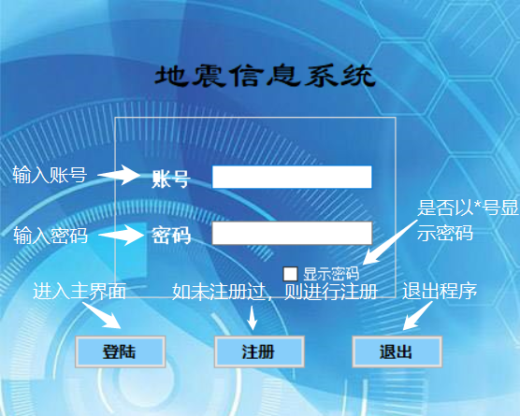

### 4.1.1登陆

private void button1_Click(object sender, EventArgs e)

{

string id = textBox1.Text.Trim();

string password = textBox2.Text.Trim();

string str1 = "SELECT * FROM account WHERE id='" + id + "' and password='" + password + "'";

//MessageBox.Show(str1);

SqlCommand mycmd = new SqlCommand(str1,myconn);

myconn.Open();

{

SqlDataReader myreader=mycmd.ExecuteReader();

if (myreader.HasRows == false)

{

MessageBox.Show("账号或密码错误！");

textBox1.Text = "";

textBox2.Text = "";

textBox1.Focus();

}

else

{

MessageBox.Show("登陆成功！");

this.Hide();

Form0 f0 = new Form0();

f0.ShowDialog();

if (f0.DialogResult == DialogResult.Cancel)

this.Close();

}

}

myconn.Close();

}

### 4.1.2是否以*号显示密码

private void checkBox1_CheckedChanged(object sender, EventArgs e)

{

if (checkBox1.Checked == true)

textBox2.PasswordChar = new char();

else

textBox2.PasswordChar = '*';

}

### 4.1.3退出

private void button3_Click(object sender, EventArgs e)

{

this.Close();

}

### 4.1.4注册

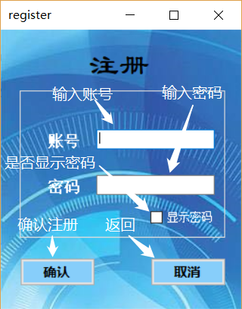

private void button1_Click(object sender, EventArgs e)

{

bool a = false;

string id = textBox1.Text.Trim();

string password = textBox2.Text.Trim();

string str1 = "SELECT * FROM account WHERE id='" + id + "'";

string str2 = "INSERT INTO account VALUES ('" + id + "','" + password + "');";

//MessageBox.Show(str2);

SqlCommand mycmd = new SqlCommand(str1, myconn);

SqlCommand mycmd1 = new SqlCommand(str2, myconn);

myconn.Open();

{

SqlDataReader myreader = mycmd.ExecuteReader();

if (id == "" || password == "")

{

MessageBox.Show("账号和密码不能为空！");

}

else if (myreader.HasRows == true)

{

MessageBox.Show("账号已经存在！");

textBox1.Text = "";

textBox2.Text = "";

}

else

{

myreader.Close();

mycmd1.ExecuteNonQuery();

MessageBox.Show("注册成功！");

a = true;

}

}

myconn.Close();

if (a)

Close();

}

### 4.1.5取消（从注册界面返回登录界面）

private void register_FormClosed(object sender, FormClosedEventArgs e)

{

DialogResult = DialogResult.Cancel;

}

private void button2_Click(object sender, EventArgs e)

{

this.Close();

}

4.2首页

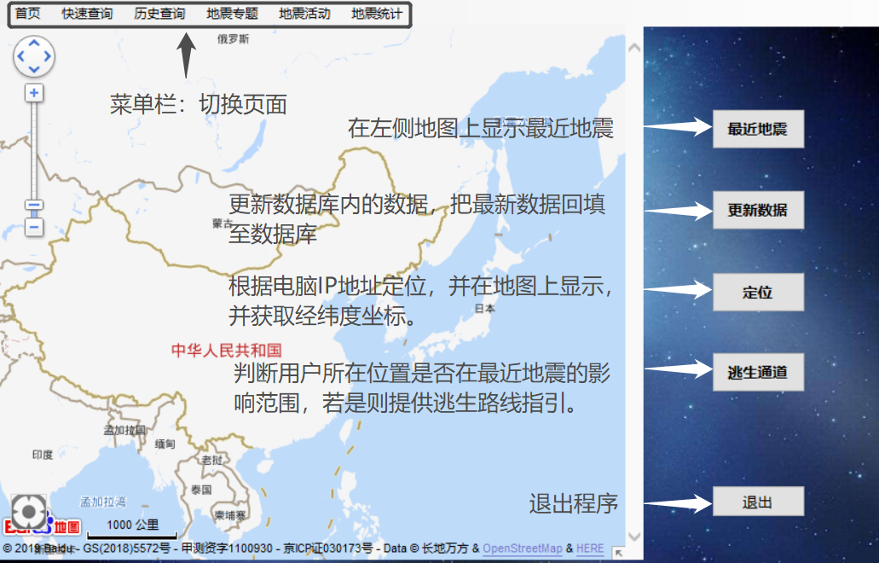

### **4.2.1菜单栏**

代码：

private void 历史查询ToolStripMenuItem_Click(object sender, EventArgs e)

{

DialogResult = DialogResult.Cancel;

this.Hide();

Form1 f1 = new Form1();

f1.ShowDialog();

if (f1.DialogResult == DialogResult.Cancel)

this.Close();

}

private void 快速查询ToolStripMenuItem_Click(object sender, EventArgs e)

{

DialogResult = DialogResult.Cancel;

this.Hide();

Form2 f2 = new Form2();

f2.ShowDialog();

if (f2.DialogResult == DialogResult.Cancel)

this.Close();

}

private void 地震活动ToolStripMenuItem_Click(object sender, EventArgs e)

{

DialogResult = DialogResult.Cancel;

this.Hide();

Form4 f4 = new Form4();

f4.ShowDialog();

if (f4.DialogResult == DialogResult.Cancel)

this.Close();

}

private void 地震统计ToolStripMenuItem_Click(object sender, EventArgs e)

{

DialogResult = DialogResult.Cancel;

this.Hide();

Form5 f5 = new Form5();

f5.ShowDialog();

if (f5.DialogResult == DialogResult.Cancel)

this.Close();

}

private void 地震信息ToolStripMenuItem_Click(object sender, EventArgs e)

{

DialogResult = DialogResult.Cancel;

this.Hide();

Form6 f6 = new Form6();

f6.ShowDialog();

if (f6.DialogResult == DialogResult.Cancel)

this.Close();

}

private void For0_FormClosed(object sender, FormClosedEventArgs e)

{

DialogResult = DialogResult.Cancel;

}

### **4.2.2最近地震显示**

**代码：**

private void button1_Click(object sender, EventArgs e)

{

string[] strArr = new string[2];//参数列表

string sArguments = Application.StartupPath + @"\5211.py";//这里是python的文件名字

strArr[0] = "2";

strArr[1] = "3";

RunPythonScript(sArguments, "-u", strArr);

Workbook workbook1 = new Workbook();

workbook1.LoadFromFile(Application.StartupPath + "\\earthquake.xls");

Worksheet sheet1 = workbook1.Worksheets[0];

//显示出来

DataTable datatable = new DataTable();

//载入Excel文档

Workbook workbook2 = new Workbook();

workbook2.LoadFromFile(Application.StartupPath + "\\earthquake.xls");

//获取第一个工作表

Worksheet sheet2 = workbook2.Worksheets[0];

//将第一个工作表的数据导出到datatable中

datatable = sheet2.ExportDataTable();

double[] arraywei = new double[datatable.Rows.Count];

for (int i = 0; i < datatable.Rows.Count; i++)

{

DataRow datar = datatable.Rows[i];

arraywei[i] = Convert.ToDouble(datar["纬度"]);

//listBox1.Items.Add(arraywei[i]);

}

double[] arrayjing = new double[datatable.Rows.Count];

for (int i = 0; i < datatable.Rows.Count; i++)

{

DataRow datar = datatable.Rows[i];

arrayjing[i] = Convert.ToDouble(datar["经度"]);

//listBox2.Items.Add(arrayjing[i]);

}

string[] arrayxin = new string[datatable.Rows.Count];

for (int i = 0; i < datatable.Rows.Count; i++)

{

DataRow datar = datatable.Rows[i];

arrayxin[i] = "震级大小：" + Convert.ToString(datar["震级大小"]) + ";发生地点：" + Convert.ToString(datar["地点"]) +

";发生时间:" + Convert.ToString(datar["时间"]) + ";经纬度:" + Convert.ToString(datar["经度"]) + "，" + Convert.ToString(datar["纬度"]);

}

for (int j = 0; j < datatable.Rows.Count; j++)

{

addpoint(arrayjing[j], arraywei[j], arrayxin[j]);

}

}

### **4.2.3数据更新**

代码：

static string earthquake = "Data Source=.;Initial Catalog=earthquake;Integrated Security=True";

private void button2_Click(object sender, EventArgs e)//更新数据

{

string[] strArr = new string[2];//参数列表

string sArguments = Application.StartupPath + @"\5211.py";//这里是python的文件名字

strArr[0] = "2";

strArr[1] = "3";

RunPythonScript(sArguments, "-u", strArr);

DataTable datatable = new DataTable();

Workbook workbook = new Workbook();

workbook.LoadFromFile(Application.StartupPath + "\\earthquake.xls");

Worksheet sheet = workbook.Worksheets[0];

datatable = sheet.ExportDataTable();

SqlConnection conn = new SqlConnection(earthquake);

for (int i = 0; i < datatable.Rows.Count; i++)

{

DataRow datar = datatable.Rows[i];

object[] row = { Convert.ToString(datar["时间"]), Convert.ToDouble(datar["震级大小"]), Convert.ToDouble(datar["纬度"]), Convert.ToDouble(datar["经度"]), Convert.ToDouble(datar["震源深度"]), Convert.ToString(datar["地点"]) };

string strupdate = "insert into Table1$ values ('" + row[0].ToString() + "'," + row[1].ToString() + "," + row[2].ToString() + "," + row[3].ToString() + "," + row[4].ToString() + ",'" + row[5].ToString() + "')";

SqlCommand mycmd = new SqlCommand(strupdate, conn);

conn.Open();

{

try

{

mycmd.ExecuteNonQuery();

}

catch (Exception ex)

{

MessageBox.Show("更新失败!");

}

}

conn.Close();

}

MessageBox.Show("更新成功!");

}

### **4.2.4定位**

**代码：**

private void button4_Click(object sender, EventArgs e)

{

webBrowser1.Document.InvokeScript("getlocation");

}

### **4.2.5逃生通道**

代码：

private void button3_Click(object sender, EventArgs e)

{

if (state == 0)

{

MessageBox.Show("还未定位");

return;

}

else

{

DataTable datatable = new DataTable();

Workbook workbook = new Workbook();

workbook.LoadFromFile(Application.StartupPath + "\\earthquake.xls");

Worksheet sheet = workbook.Worksheets[0];

datatable = sheet.ExportDataTable();

double distance = 0;

int Rows = datatable.Rows.Count;

double[] earthjing = new double[Rows];

double[] earthwei = new double[Rows];

double[] earthmag = new double[Rows];

string[] happentime = new string[Rows];

for (int i = 0; i < datatable.Rows.Count; i++)

{

DataRow datar = datatable.Rows[i];

earthjing[i] = Convert.ToDouble(datar["经度"]);

earthwei[i] = Convert.ToDouble(datar["纬度"]);

earthmag[i] = Convert.ToDouble(datar["震级大小"]);

happentime[i] = Convert.ToString(datar["时间"]);

}

int clc = 0;//判断是否出消息

//获取当前时间

string time = DateTime.Now.ToString("yyyy-MM-dd");

for (int i = 0; i < datatable.Rows.Count; i++)

{

distance = 0;

bool delttime = happentime[i].StartsWith(time);

if (delttime)

{

if (earthmag[i] > 6)//如果地震

{

distance = getdistance(locajin, locawei, earthjing[i], earthwei[i]);

if (distance < 150)

{

MessageBox.Show("有强烈震感!距离震源" + distance.ToString() + "公里！将为您指出最近的避难路线。");

showway(); clc = 1;

}

}

else if (earthmag[i] > 7)

{

distance = getdistance(locajin, locawei, earthjing[i], earthwei[i]);

if (distance < 300)

{

MessageBox.Show("有强烈震感!距离震源" + distance.ToString() + "公里！将为您指出最近的避难路线。");

showway(); clc = 1;

}

}

else if (earthmag[i] > 8)

{

distance = getdistance(locajin, locawei, earthjing[i], earthwei[i]);

if (distance < 500)

{

MessageBox.Show("有强烈震感!距离震源" + distance.ToString() + "公里！将为您指出最近的避难路线。");

showway(); clc = 1;

}

}

else if (earthmag[i] > 9)

{

distance = getdistance(locajin, locawei, earthjing[i], earthwei[i]);

if (distance < 700)

{

MessageBox.Show("有强烈震感!距离震源" + distance.ToString() + "公里！将为您指出最近的避难路线。");

showway(); clc = 1;

}

}

else

{

}

}

}

if (clc == 0)

{

MessageBox.Show("无强烈震感!距离震源较远！不必担心");

}

}

}

public void LngInfo(string message)

{

locajin = Convert.ToDouble(message);

//listBox1.Items.Add(locajin);

state = 1;

}

public void LatInfo(string message)

{

locawei = Convert.ToDouble(message);

//listBox1.Items.Add(locawei);

state = 1;

}

static double EARTH_RADIUS = 6378.137;

private double getdistance(double lat1, double lng1, double lat2, double lng2)//建立大地坐标系，经纬度算距离

{ double radLat1 = lat1 *Math.PI / 180.0; //角度1˚ = π / 180

double radLat2 = lat2 * Math.PI/ 180.0; //角度1˚ = π / 180

double a = radLat1 - radLat2;//纬度之差

double b = lng1 * Math.PI / 180.0 - lng2* Math.PI/ 180.0; //经度之差

double dst = 2 * Math.Asin((Math.Sqrt(Math.Pow(Math.Sin(a / 2), 2) + Math.Cos(radLat1) * Math.Cos(radLat2) * Math.Pow(Math.Sin(b / 2), 2))));

dst = dst * EARTH_RADIUS;

dst = Math.Round(dst * 10000) / 10000;

return dst;

}

private double[] recentemer(double x1,double y1)

{

double[] point = new double[2];

string str = @"Data Source=.;Initial Catalog=上海;Integrated Security=True";

SqlConnection myconn = new SqlConnection(str);

DataSet mydataset = new DataSet();

string strsearch = @"select lab,lng,场所名称 from emergency";

SqlDataAdapter myadapter = new SqlDataAdapter(strsearch, myconn);

myadapter.Fill(mydataset,"经纬度");

double distancemin = 1000; double distance = 0; int k = 0;

for (int i = 0; i < mydataset.Tables["经纬度"].Rows.Count; i++)

{

distance = getdistance(x1, y1, Convert.ToDouble(mydataset.Tables["经纬度"].Rows[i].ItemArray[0]), Convert.ToDouble(mydataset.Tables["经纬度"].Rows[i].ItemArray[1]));

if(distance<distancemin)

{

distancemin=distance;

point[0]=Convert.ToDouble(mydataset.Tables["经纬度"].Rows[i].ItemArray[0]);

point[1]=Convert.ToDouble(mydataset.Tables["经纬度"].Rows[i].ItemArray[1]);

k = i;

}

}

MessageBox.Show("最近的是" +Convert.ToString(mydataset.Tables["经纬度"].Rows[k].ItemArray[2])+ "应急避难所");

return point;

}

private void showway()

{

string lng = webBrowser1.Document.GetElementById("lng").InnerText;

string lat = webBrowser1.Document.GetElementById("lat").InnerText;

locajin = Convert.ToDouble(lng);

locawei = Convert.ToDouble(lat);

object[] objects1 = new object[4];

objects1[0] = locajin;

objects1[1] = locawei;

double[] point = recentemer(Convert.ToDouble(objects1[1]), Convert.ToDouble(objects1[0]));

objects1[2] = point[1];

objects1[3] = point[0];

webBrowser1.Document.InvokeScript("findemergency", objects1);

}

### 4.2.6退出：

**代码：**

private void button5_Click(object sender, EventArgs e)

{

this.Close();

}

### **注1**：4.2.2和4.2.3都需要调用python程序

**C#内代码：**

//调用python核心代码

public static void RunPythonScript(string sArgName, string args = "", params string[] teps)

{

Process p = new Process();

string path = Application.StartupPath + @"\5211.py";// 获得python文件的绝对路径（将文件放在c#的debug文件夹中可以这样操作）

p.StartInfo.FileName = @"D:\anaconda\python.exe";//没有配环境变量的话，可以像我这样写python.exe的绝对路径。如果配了，直接写"python.exe"即可

string sArguments = path;

foreach (string sigstr in teps)

{

sArguments += " " + sigstr;//传递参数

}

sArguments += " " + args;

p.StartInfo.Arguments = sArguments;

p.StartInfo.UseShellExecute = false;

p.StartInfo.RedirectStandardOutput = true;

p.StartInfo.RedirectStandardInput = true;

p.StartInfo.RedirectStandardError = true;

p.StartInfo.CreateNoWindow = true;

p.Start();

p.BeginOutputReadLine();

p.OutputDataReceived += new DataReceivedEventHandler(p_OutputDataReceived);

Console.ReadLine();

p.WaitForExit();

}

//输出打印的信息

static void p_OutputDataReceived(object sender, DataReceivedEventArgs e)

{

if (!string.IsNullOrEmpty(e.Data))

{

Console.WriteLine(e.Data + Environment.NewLine);

}

}

**Python代码：**

**import urllib.request**

**import turtle**

**import matplotlib.pyplot as plt**

**from bs4 import BeautifulSoup**

**import xlwt**

**#from pymssql import \***

**def readhtml(url):**

**try:**

**head={}**

**data={}**

**head['User-Agent']="Mozilla/5.0 (Windows NT 6.1; WOW64) AppleWebKit/537.36 (KHTML, like Gecko) Chrome/45.0.2454.101 Safari/537.36"**

**req=urllib.request.Request(url,data,head)**

**response=urllib.request.urlopen(req)**

**html=response.read()**

**html=html.decode('utf-8')**

**return html**

**except:**

**return ""**

**def analyze(html,alist,datalinks):**

**soup=BeautifulSoup(html,'html.parser')**

**datalinks=soup.find_all('tr')**

**for i in datalinks:**

**x=i.find_all('td')**

**if len(x)==0:**

**continue**

**blist=[]**

**for y in x:**

**blist.append(y.string)**

**alist.append(blist)**

**def datacollect(alist,zlist,ilist):**

**for i in range(30):**

**x=alist[i]**

**ilist.append(int(x[4]))**

**zlist.append(float(x[0]))**

**def filedeal(alist):**

**g=["震级大小","时间","纬度","经度","震源深度","地点"]**

**datas=[]**

**datas.append(g)**

**for i in range(len(alist)):**

**datas.append(alist[i])#二维数组**

**file_path = r'earthquake.xls'**

**wb = xlwt.Workbook()**

**sheet = wb.add_sheet('test')#sheet的名称为test**

**#单元格的格式**

**style = 'pattern: pattern solid, fore_colour yellow; '#背景颜色为黄色**

**style += 'font: bold on; '#粗体字**

**style += 'align: horz centre, vert center; '#居中**

**header_style = xlwt.easyxf(style)**

**row_count = len(datas)**

**col_count = len(datas[0])**

**for row in range(0, row_count):**

**col_count = len(datas[row])**

**for col in range(0, col_count):**

**if row == 0:#设置表头单元格的格式**

**sheet.write(row, col, datas[row][col], header_style)**

**else:**

**sheet.write(row, col, datas[row][col])**

**wb.save(file_path)**

**def collecttime(alist,plist,olist):**

**for i in range(30):**

**x=alist[i]**

**plist.append(str(x[1]))**

**for y in plist:**

**i=y.replace(' ','')**

**g=i.replace('-','')**

**v=g.replace(':','')**

**w=int(v)**

**w=w+1**

**e=str(w)**

**olist.append(e)**

**def filetohtml(alist,olist):**

**txt='<table border="1">'**

**txt=txt+'\n'+'<h1 style="text-align:center">'+"最新地震信息"+'</h1>'**

**txt=txt+'\n'+'<tr>'**

**g=["震级大小","时间","纬度","经度","震源深度","地点"]**

**for f in range(6):**

**txt=txt+'\n'+"<td>"+str(g[f])+"</td>"**

**txt=txt+'\n'+'</tr>'**

**for i in range(30):**

**txt=txt+'\n'+'<tr>'**

**x=alist[i]**

**for f in range(6):**

**if f<5:**

**txt=txt+'\n'+"<td>"+str(x[f])+"</td>"**

**else:**

**txt=txt+'\n'+"<td>"+"<a href="'http://news.ceic.ac.cn/CD'+olist[i]+'.html'">"+str(x[f])+"</a>"+"</td>"**

**txt=txt+'\n'+'</tr>'**

**txt=txt+'\n'+'</table>'**

**txt=txt+'\n'+'<h2 style="text-align:center">'+"地震网站链接"+'</h2>'**

**txt=txt+'\n'+"<a href="'http://www.ceic.ac.cn/'">"+"中国地震台网"+"</a>"**

**txt=txt+'\n'+"<a href="'https://earthquake.usgs.gov/earthquakes/map/'">美国地质勘探局</a>"**

**txt=txt+'\n'+"<a href="'https://www.emsc-csem.org/#2'">欧洲地中海地震观测中心</a>"**

**fileh=open(r'C:\Users\DELL\Desktop\earthquake.html','w')**

**fileh.write(txt)**

**fileh.close()**

**def draw(ilist,zlist):**

**yValues = ilist**

**zvalues=zlist**

**t = turtle.Turtle()**

**t.hideturtle()**

**drawLine(t,-300,-250,300,-250)**

**drawLine(t,-300,-250,-300,350)**

**for i in range(29):**

**drawLineWithDots(t,20 + (20 * i)-300,4 * yValues[i]-250,20 + (20 * (i+1))-300,4 * (yValues[i+1])-250,"blue")**

**t.up()**

**for i in range(30):**

**t.goto(20 + (20 * i)-300,4 * yValues[i]-240)**

**t.write(str(zvalues[i]),align="center")**

**drawTickMarks(t,yValues)**

**displayText(t,yValues)**

**ts = turtle.getscreen()**

**ts.getcanvas().postscript(file="work.eps")**

**def drawLine(t,x1,y1,x2,y2,colorP="black"):**

**t.up()**

**t.goto(x1,y1)**

**t.down()**

**t.pencolor(colorP)**

**t.goto(x2,y2)**

**def drawLineWithDots(t,x1,y1,x2,y2,colorP="black"):**

**t.pencolor(colorP)**

**t.up()**

**t.goto(x1,y1)**

**t.dot(5)**

**t.down()**

**t.goto(x2,y2)**

**t.dot(5)**

**def drawTickMarks(t,yValues):**

**for i in range(1,31):**

**drawLine(t,20*i-300,-250,20*i-300,-240)**

**for i in range(1,15):**

**drawLine(t,-300,-250+40*i,-290,-250+40*i)**

**def displayText(t,yValues):**

**t.pencolor("blue")**

**t.up()**

**t.goto(-310,(4*max(yValues))-250)**

**t.write(max(yValues),align="center")**

**t.goto(-310,(4*min(yValues))-250)**

**t.write(min(yValues),align="center")**

**x = 0**

**for i in range(0,32,2):**

**t.goto(x-300,-270)**

**t.write(str(i),align="center")**

**x += 40**

**t.goto(320,-270)**

**t.write("地震",font=("Arial",8,"normal"))**

**y = -255**

**for i in range(0,15):**

**t.goto(-313,y)**

**t.write(str(i*10),align="center")**

**y += 40**

**t.goto(-340,0)**

**t.write("震源深度/km",font=("Arial",8,"normal"))**

**t.goto(-100,-300)**

**t.write("地震震源深度分析表",font=("Arial",16,"normal"))**

**def getxy(alist,xlist,ylist):**

**for i in range(30):**

**x=alist[i]**

**xlist.append(int(float(x[2])))**

**ylist.append(int(float(x[3])))**

**def drawaddress(xlist,ylist):**

**plt.plot()**

**plt.title(" 地震信号分析表 ")**

**plt.xlim(xmax=300,xmin=-300)**

**plt.ylim(ymax=300,ymin=-300)**

**plt.xlabel("x")**

**plt.ylabel("y")**

**plt.plot(xlist,ylist,'r.')**

**plt.show()**

**def main():**

**print("地震信息收集系统")**

**zlist=[]**

**alist=[]**

**ilist=[]**

**datalinks=[]**

**xlist=[]**

**ylist=[]**

**olist=[]**

**plist=[]**

**url="http://www.ceic.ac.cn/"**

**html=readhtml(url)**

**analyze(html,alist,datalinks)**

**collecttime(alist,plist,olist)**

**filedeal(alist)**

**filetohtml(alist,olist)**

**datacollect(alist,zlist,ilist)**

**getxy(alist,xlist,ylist)**

**#draw(ilist,zlist)**

**#drawaddress(xlist,ylist)**

**if __name__=='__main__':**

**main()**

### **注2**：4.2.4需要用到JavaScript代码

<!DOCTYPE html>

<html>

<head>

<meta http-equiv="Content-Type" content="text/html; charset=utf-8" />

<meta name="viewport" content="initial-scale=1.0, user-scalable=no" />

<style type="text/css">

body, html {width: 100%;height: 100%;margin:0;font-family:"微软雅黑";}

#allmap{width:100%;height:100%;}

p{margin-left:5px; font-size:14px;}

</style>

<script type="text/javascript" src="http://api.map.baidu.com/api?v=2.0&ak=5H81a8zEwctwf081w60uwCbt0ZktgwL2"></script>

<title>map</title>

</head>

<body>

<div id="allmap"></div>

<div id="lng" style="display:none"></div>

<div id="lat" style="display:none"></div>

</body>

</html>

<script type="text/javascript">

var map = new BMap.Map("allmap");

map.centerAndZoom(new BMap.Point(116.404, 39.915), 4);

map.addControl(new BMap.ScaleControl());// 添加相关控件

map.addControl(new BMap.OverviewMapControl());// 添加相关控件

var ctrl_nav = new BMap.NavigationControl({ anchor: BMAP_ANCHOR_TOP_LEFT, type: BMAP_NAVIGATION_CONTROL_LARGE });

map.addControl(ctrl_nav) ;// 添加相关控件

map.enableDragging();

map.enableScrollWheelZoom()

map.enableDoubleClickZoom();

map.enableKeyboard();

map.enableContinuousZoom();

map.enableInertialDragging();

var geolocationControl = new BMap.GeolocationControl();

geolocationControl.addEventListener("locationSuccess", function(e){

// 定位成功事件

var address = '';

address += e.addressComponent.province;

address += e.addressComponent.city;

address += e.addressComponent.district;

address += e.addressComponent.street;

address += e.addressComponent.streetNumber;

alert("当前定位地址为：" + address);

});

geolocationControl.addEventListener("locationError",function(e){

// 定位失败事件

alert(e.message);

});

map.addControl(geolocationControl);

function openGetDistance() {

var myDis=new BMapLib.DistanceTool(map);//mapΪɏæґ¾­³õʼ»¯ºõĵ؍¼ʵÀý

myDis.open();

}

var marker_num = 0;

var isAddListen = -1;

function ClearAllMarkers() {

map.clearOverlays();

marker_num = 0;

isAddListen = -1;

}

function CloseListener() {

map.removeEventListener("rightclick", putmarker);

}

function FindPosition(CurLng, CurLat) {

var point = new BMap.Point(CurLng, CurLat);

map.centerAndZoom(point, 20);

}

var Lng = 116.380960

var Lat = 39.913280

function GetTestGPS(CurLng, CurLat) {

var point = new BMap.Point(CurLng, CurLat);

map.centerAndZoom(point, 20);

window.external.LocateInfo(text);

return Lng;

}

function GetTest2GPS() {

var text = '{"Point":[{"x":"116.380960","y":"39.913280"},{"x":"116.380961","y":"39.913281"},{"x":"116.380962","y":"39.913282"},{"x":"116.380963","y":"39.913283"}]}'

window.external.LocateInfo(text);

return text;

}

function myTimer(JinDu, WeiDu, str)

{

var BaiDuPoint = new BMap.Point(JinDu, WeiDu);

map.centerAndZoom(BaiDuPoint, 17);

var marker = new BMap.Marker(BaiDuPoint);

map.addOverlay(marker);

//map.openInfoWindow(infoWindow, BaiDuPoint);

//map.setCenter(BaiDuPoint); //Ҕµ±ǰµėø±굣Ϊ֐Єϔʾ

var label = new BMap.Label(str,{offset:new BMap.Size(20,-10)});

marker.setLabel(label);

}

function addmarkerinfo(jingdu,weidu,wenzi)

{

var point = new BMap.Point(jingdu , weidu);

var marker = new BMap.Marker(point); // 创建标注

var content = wenzi;

map.addOverlay(marker); // 将标注添加到地图中

addClickHandler(content,marker);

}

function addClickHandler(content,marker){

marker.addEventListener("click",function(e){

openInfo(content,e)}

);

}

function openInfo(content,e){

var p = e.target;

var opts = {

width : 250, // 信息窗口宽度

height: 100, // 信息窗口高度

title : "信息窗口" , // 信息窗口标题

enableMessage:true//设置允许信息窗发送短息

};

var point = new BMap.Point(p.getPosition().lng, p.getPosition().lat);

var infoWindow = new BMap.InfoWindow(content,opts); // 创建信息窗口对象

map.openInfoWindow(infoWindow,point); //开启信息窗口

}

function getlocation()

{var geolocation = new BMap.Geolocation();

geolocation.getCurrentPosition(function(r){

if(this.getStatus() == BMAP_STATUS_SUCCESS){

//var pt = new BMap.Point(116.417, 39.909);

var myIcon = new BMap.Icon("http://lbsyun.baidu.com/jsdemo/img/fox.gif", new BMap.Size(300,157));

var markerspe = new BMap.Marker(r.point,{icon:myIcon}); // 创建标注

map.addOverlay(markerspe); // 将标注添加到地图中

var mk = new BMap.Marker(r.point);

map.addOverlay(mk);

mk.setAnimation(BMAP_ANIMATION_BOUNCE);

map.panTo(r.point);

alert('您的位置：'+r.point.lng+','+r.point.lat);

document.getElementById("lng").innerText = r.point.lng;

document.getElementById("lat").innerText = r.point.lat;

lnginfo=r.point.lng.toString();

latinfo=r.point.lat.toString();

window.external.Lnginfo(lnginfo);

window.external.Latinfo(latinfo);

}

else {

alert('failed'+this.getStatus());

}

},{enableHighAccuracy: true})

}

function findemergency(x1,y1,x2,y2){

var p1 = new BMap.Point(x1,y1);

var p2 = new BMap.Point(x2,y2);

var walking = new BMap.WalkingRoute(map, {renderOptions: {map: map, panel: "r-result", autoViewport: true}});

walking.search(p1, p2);

}

</script>

4.3快捷查询

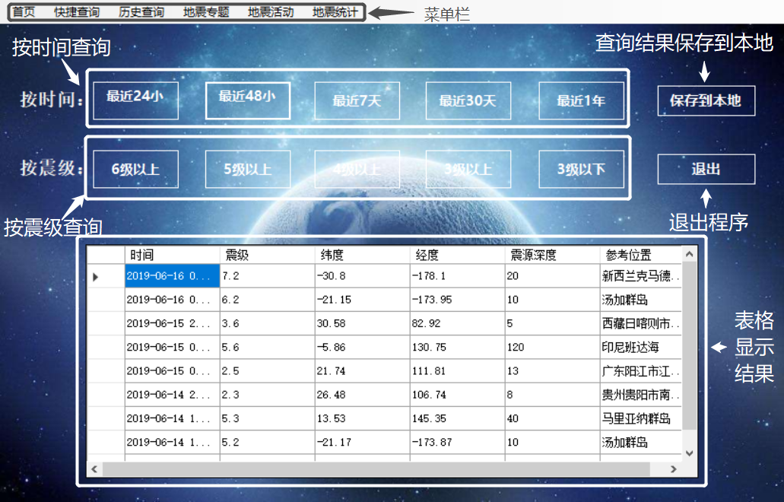

### **4.3.1菜单栏**

代码：

private void 历史查询ToolStripMenuItem_Click(object sender, EventArgs e)

{

DialogResult = DialogResult.Cancel;

this.Hide();

Form1 f1 = new Form1();

f1.ShowDialog();

if (f1.DialogResult == DialogResult.Cancel)

this.Close();

}

private void 快速查询ToolStripMenuItem_Click(object sender, EventArgs e)

{

DialogResult = DialogResult.Cancel;

this.Hide();

Form2 f2 = new Form2();

f2.ShowDialog();

if (f2.DialogResult == DialogResult.Cancel)

this.Close();

}

private void 地震活动ToolStripMenuItem_Click(object sender, EventArgs e)

{

DialogResult = DialogResult.Cancel;

this.Hide();

Form4 f4 = new Form4();

f4.ShowDialog();

if (f4.DialogResult == DialogResult.Cancel)

this.Close();

}

private void 地震统计ToolStripMenuItem_Click(object sender, EventArgs e)

{

DialogResult = DialogResult.Cancel;

this.Hide();

Form5 f5 = new Form5();

f5.ShowDialog();

if (f5.DialogResult == DialogResult.Cancel)

this.Close();

}

private void 地震信息ToolStripMenuItem_Click(object sender, EventArgs e)

{

DialogResult = DialogResult.Cancel;

this.Hide();

Form6 f6 = new Form6();

f6.ShowDialog();

if (f6.DialogResult == DialogResult.Cancel)

this.Close();

}

### **4.3.2 查询按钮**

1、查询最近24小时：

private void button1_Click(object sender, EventArgs e)

{

SqlDataAdapter myadapter1 = new SqlDataAdapter("select F1 as 时间,F2 as 震级,F3 as 纬度,F4 as 经度,F5 as 震源深度,F6 as 参考位置 from Table1$ where (getdate()-cast(F1 as datetime))<=1", myconn);

DataSet mydataset = new DataSet();

myadapter1.Fill(mydataset, "ear");

dataGridView1.DataSource = mydataset.Tables["ear"];

}

2、查询最近48小时：

private void button2_Click(object sender, EventArgs e)

{

SqlDataAdapter myadapter1 = new SqlDataAdapter("select F1 as 时间,F2 as 震级,F3 as 纬度,F4 as 经度,F5 as 震源深度,F6 as 参考位置 from Table1$ where (getdate()-cast(F1 as datetime))<=2", myconn);

DataSet mydataset = new DataSet();

myadapter1.Fill(mydataset, "ear");

dataGridView1.DataSource = mydataset.Tables["ear"];

}

3、查询最近7天：

private void button3_Click(object sender, EventArgs e)

{

SqlDataAdapter myadapter1 = new SqlDataAdapter("select F1 as 时间,F2 as 震级,F3 as 纬度,F4 as 经度,F5 as 震源深度,F6 as 参考位置 from Table1$ where (getdate()-cast(F1 as datetime))<=7", myconn);

DataSet mydataset = new DataSet();

myadapter1.Fill(mydataset, "ear");

dataGridView1.DataSource = mydataset.Tables["ear"];

}

4、查询最近30天：

private void button4_Click(object sender, EventArgs e)

{

SqlDataAdapter myadapter1 = new SqlDataAdapter("select F1 as 时间,F2 as 震级,F3 as 纬度,F4 as 经度,F5 as 震源深度,F6 as 参考位置 from Table1$ where (getdate()-cast(F1 as datetime))<=30", myconn);

DataSet mydataset = new DataSet();

myadapter1.Fill(mydataset, "ear");

dataGridView1.DataSource = mydataset.Tables["ear"];

}

5、查询最近1年：

private void button5_Click(object sender, EventArgs e)

{

SqlDataAdapter myadapter1 = new SqlDataAdapter("select F1 as 时间,F2 as 震级,F3 as 纬度,F4 as 经度,F5 as 震源深度,F6 as 参考位置 from Table1$ where (getdate()-cast(F1 as datetime))<=365", myconn);

DataSet mydataset = new DataSet();

myadapter1.Fill(mydataset, "ear");

dataGridView1.DataSource = mydataset.Tables["ear"];

}

6、查询大于6级：

private void button6_Click(object sender, EventArgs e)

{

SqlDataAdapter myadapter1 = new SqlDataAdapter("select F1 as 时间,F2 as 震级,F3 as 纬度,F4 as 经度,F5 as 震源深度,F6 as 参考位置 from Table1$ where F2>6", myconn);

DataSet mydataset = new DataSet();

myadapter1.Fill(mydataset, "ear");

dataGridView1.DataSource = mydataset.Tables["ear"];

}

7、查询大于5级：

private void button7_Click(object sender, EventArgs e)

{

SqlDataAdapter myadapter1 = new SqlDataAdapter("select F1 as 时间,F2 as 震级,F3 as 纬度,F4 as 经度,F5 as 震源深度,F6 as 参考位置 from Table1$ where F2>5", myconn);

DataSet mydataset = new DataSet();

myadapter1.Fill(mydataset, "ear");

dataGridView1.DataSource = mydataset.Tables["ear"];

}

8、查询大于4级：

private void button8_Click(object sender, EventArgs e)

{

SqlDataAdapter myadapter1 = new SqlDataAdapter("select F1 as 时间,F2 as 震级,F3 as 纬度,F4 as 经度,F5 as 震源深度,F6 as 参考位置 from Table1$ where F2>4", myconn);

DataSet mydataset = new DataSet();

myadapter1.Fill(mydataset, "ear");

dataGridView1.DataSource = mydataset.Tables["ear"];

}

9、查询大于3级：

private void button9_Click(object sender, EventArgs e)

{

SqlDataAdapter myadapter1 = new SqlDataAdapter("select F1 as 时间,F2 as 震级,F3 as 纬度,F4 as 经度,F5 as 震源深度,F6 as 参考位置 from Table1$ where F2>3", myconn);

DataSet mydataset = new DataSet();

myadapter1.Fill(mydataset, "ear");

dataGridView1.DataSource = mydataset.Tables["ear"];

}

10：查询小于3级：

private void button10_Click(object sender, EventArgs e)

{

SqlDataAdapter myadapter1 = new SqlDataAdapter("select F1 as 时间,F2 as 震级,F3 as 纬度,F4 as 经度,F5 as 震源深度,F6 as 参考位置 from Table1$ where F2<3", myconn);

DataSet mydataset = new DataSet();

myadapter1.Fill(mydataset, "ear");

dataGridView1.DataSource = mydataset.Tables["ear"];

}

### **4.3.3 保存本地**

public class ExportToExcel

{

public Excel.Application m_xlApp = null;

public void OutputAsExcelFile(DataGridView dataGridView)

{

if (dataGridView.Rows.Count <= 0)

{

MessageBox.Show("无数据！", "提示", MessageBoxButtons.OK, MessageBoxIcon.Warning); return;

}

string filePath = "";

SaveFileDialog s = new SaveFileDialog();

s.Title = "保存Excel文件";

s.Filter = "Excel文件(*.xls)|*.xls";

s.FilterIndex = 1;

if (s.ShowDialog() == DialogResult.OK)

filePath = s.FileName;

else

return;

//第一步：将dataGridView转化为dataTable,这样可以过滤掉dataGridView中的隐藏列

DataTable tmpDataTable = new DataTable("tmpDataTable");

DataTable modelTable = new DataTable("ModelTable");

for (int column = 0; column < dataGridView.Columns.Count; column++)

{

if (dataGridView.Columns[column].Visible == true)

{

DataColumn tempColumn = new DataColumn(dataGridView.Columns[column].HeaderText, typeof(string));

tmpDataTable.Columns.Add(tempColumn);

DataColumn modelColumn = new DataColumn(dataGridView.Columns[column].Name, typeof(string));

modelTable.Columns.Add(modelColumn);

}

}

for (int row = 0; row < dataGridView.Rows.Count; row++)

{

if (dataGridView.Rows[row].Visible == false)

continue;

DataRow tempRow = tmpDataTable.NewRow();

for (int i = 0; i < tmpDataTable.Columns.Count; i++)

tempRow[i] = dataGridView.Rows[row].Cells[modelTable.Columns[i].ColumnName].Value;

tmpDataTable.Rows.Add(tempRow);

}

if (tmpDataTable == null)

{

return;

}

//第二步：导出dataTable到Excel

long rowNum = tmpDataTable.Rows.Count;//行数

int columnNum = tmpDataTable.Columns.Count;//列数

Excel.Application m_xlApp = new Excel.Application();

m_xlApp.DisplayAlerts = false;//不显示更改提示

m_xlApp.Visible = false;

Excel.Workbooks workbooks = m_xlApp.Workbooks;

Excel.Workbook workbook = workbooks.Add(Excel.XlWBATemplate.xlWBATWorksheet);

Excel.Worksheet worksheet = (Excel.Worksheet)workbook.Worksheets[1];//取得sheet1

try

{

string[,] datas = new string[rowNum + 1, columnNum];

for (int i = 0; i < columnNum; i++) //写入字段

datas[0, i] = tmpDataTable.Columns[i].Caption;

//Excel.Range range = worksheet.get_Range(worksheet.Cells[1, 1], worksheet.Cells[1, columnNum]);

Excel.Range range = m_xlApp.Range[worksheet.Cells[1, 1], worksheet.Cells[1, columnNum]];

range.Interior.ColorIndex = 15;//15代表灰色

range.Font.Bold = true;

range.Font.Size = 10;

int r = 0;

for (r = 0; r < rowNum; r++)

{

for (int i = 0; i < columnNum; i++)

{

object obj = tmpDataTable.Rows[r][tmpDataTable.Columns[i].ToString()];

datas[r + 1, i] = obj == null ? "" : "'" + obj.ToString().Trim();//在obj.ToString()前加单引号是为了防止自动转化格式

}

System.Windows.Forms.Application.DoEvents();

//添加进度条

}

//Excel.Range fchR = worksheet.get_Range(worksheet.Cells[1, 1], worksheet.Cells[rowNum + 1, columnNum]);

Excel.Range fchR = m_xlApp.Range[worksheet.Cells[1, 1], worksheet.Cells[rowNum + 1, columnNum]];

fchR.Value2 = datas;

worksheet.Columns.EntireColumn.AutoFit();//列宽自适应。

//worksheet.Name = "dd";

//m_xlApp.WindowState = Excel.XlWindowState.xlMaximized;

m_xlApp.Visible = false;

// = worksheet.get_Range(worksheet.Cells[1, 1], worksheet.Cells[rowNum + 1, columnNum]);

range = m_xlApp.Range[worksheet.Cells[1, 1], worksheet.Cells[rowNum + 1, columnNum]];

//range.Interior.ColorIndex = 15;//15代表灰色

range.Font.Size = 9;

range.RowHeight = 14.25;

range.Borders.LineStyle = 1;

range.HorizontalAlignment = 1;

workbook.Saved = true;

workbook.SaveCopyAs(filePath);

}

catch (Exception ex)

{

MessageBox.Show("导出异常：" + ex.Message, "导出异常", MessageBoxButtons.OK, MessageBoxIcon.Warning);

}

finally

{

EndReport();

}

m_xlApp.Workbooks.Close();

m_xlApp.Workbooks.Application.Quit();

m_xlApp.Application.Quit();

m_xlApp.Quit();

MessageBox.Show("导出成功！", "提示", MessageBoxButtons.OK, MessageBoxIcon.Information);

}

private void EndReport()

{

object missing = System.Reflection.Missing.Value;

try

{

//m_xlApp.Workbooks.Close();

//m_xlApp.Workbooks.Application.Quit();

//m_xlApp.Application.Quit();

//m_xlApp.Quit();

}

catch { }

finally

{

try

{

System.Runtime.InteropServices.Marshal.ReleaseComObject(m_xlApp.Workbooks);

System.Runtime.InteropServices.Marshal.ReleaseComObject(m_xlApp.Application);

System.Runtime.InteropServices.Marshal.ReleaseComObject(m_xlApp);

m_xlApp = null;

}

catch { }

try

{

//清理垃圾进程

this.killProcessThread();

}

catch { }

GC.Collect();

}

}

private void killProcessThread()

{

ArrayList myProcess = new ArrayList();

for (int i = 0; i < myProcess.Count; i++)

{

try

{

System.Diagnostics.Process.GetProcessById(int.Parse((string)myProcess[i])).Kill();

}

catch { }

}

}

}

private void button12_Click(object sender, EventArgs e)

{

ExportToExcel d = new ExportToExcel();

d.OutputAsExcelFile(dataGridView1);

}

### 4.3.4退出

private void button11_Click(object sender, EventArgs e)

{

this.Close();

}

4.4历史查询

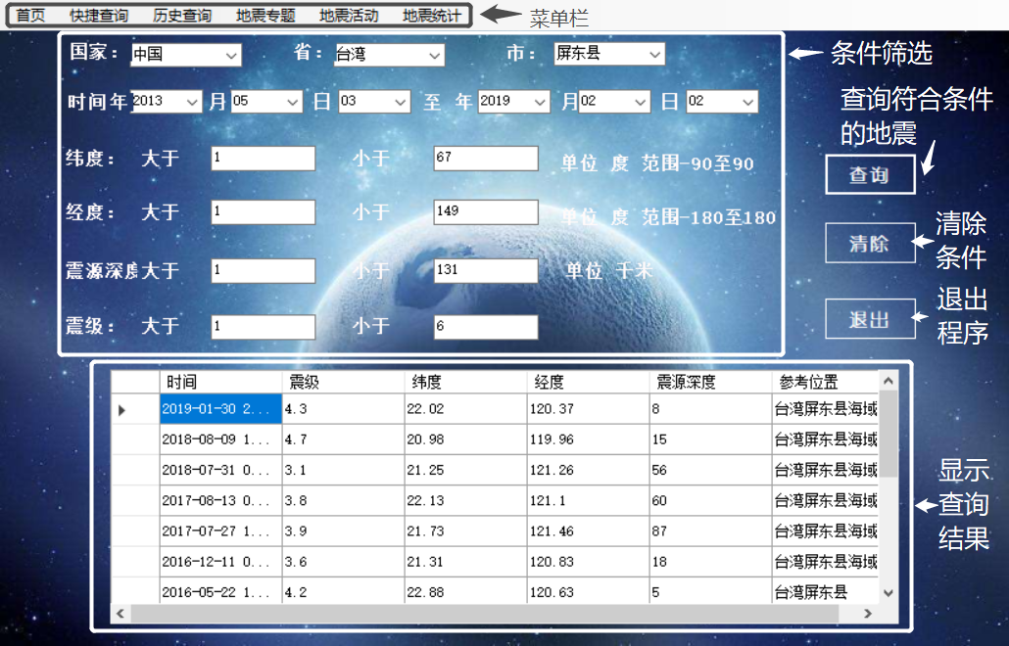

### **4.4.1菜单栏**

代码：

private void 历史查询ToolStripMenuItem_Click(object sender, EventArgs e)

{

DialogResult = DialogResult.Cancel;

this.Hide();

Form1 f1 = new Form1();

f1.ShowDialog();

if (f1.DialogResult == DialogResult.Cancel)

this.Close();

}

private void 快速查询ToolStripMenuItem_Click(object sender, EventArgs e)

{

DialogResult = DialogResult.Cancel;

this.Hide();

Form2 f2 = new Form2();

f2.ShowDialog();

if (f2.DialogResult == DialogResult.Cancel)

this.Close();

}

private void 地震活动ToolStripMenuItem_Click(object sender, EventArgs e)

{

DialogResult = DialogResult.Cancel;

this.Hide();

Form4 f4 = new Form4();

f4.ShowDialog();

if (f4.DialogResult == DialogResult.Cancel)

this.Close();

}

private void 地震统计ToolStripMenuItem_Click(object sender, EventArgs e)

{

DialogResult = DialogResult.Cancel;

this.Hide();

Form5 f5 = new Form5();

f5.ShowDialog();

if (f5.DialogResult == DialogResult.Cancel)

this.Close();

}

private void 地震信息ToolStripMenuItem_Click(object sender, EventArgs e)

{

DialogResult = DialogResult.Cancel;

this.Hide();

Form6 f6 = new Form6();

f6.ShowDialog();

if (f6.DialogResult == DialogResult.Cancel)

this.Close();

}

### 4.4.2查询

private void button1_Click(object sender, EventArgs e)

{

string a = "2012";

string b = "01";

string r = "01";

string x = "2019";

string y = "12";

string z = "31";

double c = -90;

double d = 90;

double f = -180;

double g = 180;

double h = 0;

double i = 100;

double j = 0;

double k = 100;

if (textBox1.Text != String.Empty)

{

c = Convert.ToDouble(textBox1.Text);

}

if (textBox2.Text != String.Empty)

{

d = Convert.ToDouble(textBox2.Text);

}

if (textBox3.Text != String.Empty)

{

f = Convert.ToDouble(textBox3.Text);

}

if (textBox4.Text != String.Empty)

{

g = Convert.ToDouble(textBox4.Text);

}

if (textBox5.Text != String.Empty)

{

h = Convert.ToDouble(textBox5.Text);

}

if (textBox6.Text != String.Empty)

{

i = Convert.ToDouble(textBox6.Text);

}

if (textBox7.Text != String.Empty)

{

j = Convert.ToDouble(textBox7.Text);

}

if (textBox8.Text != String.Empty)

{

k = Convert.ToDouble(textBox8.Text);

}

if (comboBox1.SelectedItem != null)

{

a = comboBox1.SelectedItem.ToString();

}

if (comboBox2.SelectedItem != null)

{

b = comboBox2.SelectedItem.ToString();

}

if (comboBox3.SelectedItem != null)

{

r = comboBox3.SelectedItem.ToString();

}

if (comboBox4.SelectedItem != null)

{

x = comboBox4.SelectedItem.ToString();

}

if (comboBox5.SelectedItem != null)

{

y = comboBox5.SelectedItem.ToString();

}

if (comboBox6.SelectedItem != null)

{

z = comboBox6.SelectedItem.ToString();

}

string con, pro, cit;

if (comboBox7.SelectedItem != null && comboBox8.SelectedItem == null && comboBox9.SelectedItem == null)

{

con = comboBox7.SelectedItem.ToString();

if (con != "中国")

{

SqlDataAdapter myadapter1 = new SqlDataAdapter("select F1 as 时间,F2 as 震级,F3 as 纬度,F4 as 经度,F5 as 震源深度,F6 as 参考位置 from Table1$ where F2>" + j.ToString() + "and F2<" + k.ToString() + " and F5>" + h.ToString() + " and F5<" + i.ToString() + " and F4>" + f.ToString() + "and F4<" + g.ToString() + " and F3>" + c.ToString() + " and F3<" + d.ToString() + "and F1 between '" + a.ToString() + "-" + b.ToString() + "-" + r.ToString() + "% 'and '" + x.ToString() + "-" + y.ToString() + "-" + z.ToString() + "%' and F6 like '%" + con.ToString() + "%'", myconn);

DataSet mydataset = new DataSet();

myadapter1.Fill(mydataset, "stu");

dataGridView1.DataSource = mydataset.Tables["stu"];

}

}

if (comboBox7.SelectedItem != null && comboBox8.SelectedItem != null && comboBox9.SelectedItem == null)

{

pro = comboBox8.SelectedItem.ToString();

con = comboBox7.SelectedItem.ToString();

if (con != "中国")

{

SqlDataAdapter myadapter1 = new SqlDataAdapter("select F1 as 时间,F2 as 震级,F3 as 纬度,F4 as 经度,F5 as 震源深度,F6 as 参考位置 from Table1$ where F2>" + j.ToString() + "and F2<" + k.ToString() + " and F5>" + h.ToString() + " and F5<" + i.ToString() + " and F4>" + f.ToString() + "and F4<" + g.ToString() + " and F3>" + c.ToString() + " and F3<" + d.ToString() + "and F1 between '" + a.ToString() + "-" + b.ToString() + "-" + r.ToString() + "% 'and '" + x.ToString() + "-" + y.ToString() + "-" + z.ToString() + "%' and F6 like '%" + con.ToString() + "%'", myconn);

DataSet mydataset = new DataSet();

myadapter1.Fill(mydataset, "stu");

dataGridView1.DataSource = mydataset.Tables["stu"];

}

else

{

SqlDataAdapter myadapter1 = new SqlDataAdapter("select F1 as 时间,F2 as 震级,F3 as 纬度,F4 as 经度,F5 as 震源深度,F6 as 参考位置 from Table1$ where F2>" + j.ToString() + "and F2<" + k.ToString() + " and F5>" + h.ToString() + " and F5<" + i.ToString() + " and F4>" + f.ToString() + "and F4<" + g.ToString() + " and F3>" + c.ToString() + " and F3<" + d.ToString() + "and F1 between '" + a.ToString() + "-" + b.ToString() + "-" + r.ToString() + "% 'and '" + x.ToString() + "-" + y.ToString() + "-" + z.ToString() + "%' and F6 like '%" + pro.ToString() + "%'", myconn);

DataSet mydataset = new DataSet();

myadapter1.Fill(mydataset, "stu");

dataGridView1.DataSource = mydataset.Tables["stu"];

}

}

if (comboBox9.SelectedItem != null)

{

cit = comboBox9.SelectedItem.ToString();

if (cit == "北京市" || cit == "上海市" || cit == "天津市" || cit == "重庆市")

{

SqlDataAdapter myadapter1 = new SqlDataAdapter("select F1 as 时间,F2 as 震级,F3 as 纬度,F4 as 经度,F5 as 震源深度,F6 as 参考位置 from Table1$ where F2>" + j.ToString() + "and F2<" + k.ToString() + " and F5>" + h.ToString() + " and F5<" + i.ToString() + " and F4>" + f.ToString() + "and F4<" + g.ToString() + " and F3>" + c.ToString() + " and F3<" + d.ToString() + "and F1 between '" + a.ToString() + "-" + b.ToString() + "-" + r.ToString() + "% 'and '" + x.ToString() + "-" + y.ToString() + "-" + z.ToString() + "%' and F6 like '%" + comboBox8.SelectedItem.ToString() + "%'", myconn);

DataSet mydataset = new DataSet();

myadapter1.Fill(mydataset, "stu");

dataGridView1.DataSource = mydataset.Tables["stu"];

}

else

{

SqlDataAdapter myadapter1 = new SqlDataAdapter("select F1 as 时间,F2 as 震级,F3 as 纬度,F4 as 经度,F5 as 震源深度,F6 as 参考位置 from Table1$ where F2>" + j.ToString() + "and F2<" + k.ToString() + " and F5>" + h.ToString() + " and F5<" + i.ToString() + " and F4>" + f.ToString() + "and F4<" + g.ToString() + " and F3>" + c.ToString() + " and F3<" + d.ToString() + "and F1 between '" + a.ToString() + "-" + b.ToString() + "-" + r.ToString() + "% 'and '" + x.ToString() + "-" + y.ToString() + "-" + z.ToString() + "%' and F6 like '%" + cit.ToString() + "%'", myconn);

DataSet mydataset = new DataSet();

myadapter1.Fill(mydataset, "stu");

dataGridView1.DataSource = mydataset.Tables["stu"];

}

}

}

### 4.4.3退出

private void button2_Click(object sender, EventArgs e)

{

this.Close();

}

4.5地震专题

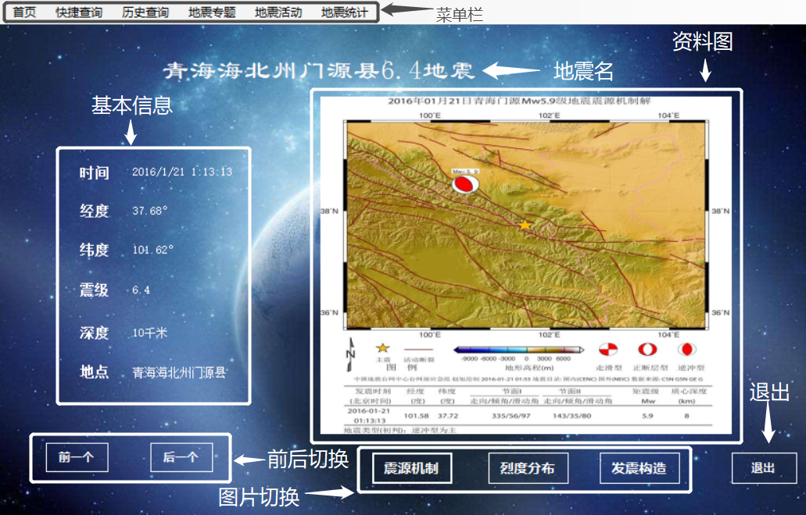

### 4.5.1菜单栏

private void 首页ToolStripMenuItem_Click(object sender, EventArgs e)

{

DialogResult = DialogResult.Cancel;

this.Hide();

Form0 f0 = new Form0();

f0.ShowDialog();

if (f0.DialogResult == DialogResult.Cancel)

this.Close();

}

private void 快捷查询ToolStripMenuItem_Click(object sender, EventArgs e)

{

DialogResult = DialogResult.Cancel;

this.Hide();

Form2 f2 = new Form2();

f2.Show();

if (f2.DialogResult == DialogResult.Cancel)

this.Close();

}

private void 历史查询ToolStripMenuItem_Click(object sender, EventArgs e)

{

DialogResult = DialogResult.Cancel;

this.Hide();

Form1 f1 = new Form1();

f1.ShowDialog();

if (f1.DialogResult == DialogResult.Cancel)

this.Close();

}

private void 地震专题ToolStripMenuItem_Click(object sender, EventArgs e)

{

}

private void 地震活动ToolStripMenuItem_Click(object sender, EventArgs e)

{

DialogResult = DialogResult.Cancel;

this.Hide();

Form4 f4 = new Form4();

f4.ShowDialog();

if (f4.DialogResult == DialogResult.Cancel)

this.Close();

}

private void 地震统计ToolStripMenuItem_Click(object sender, EventArgs e)

{

DialogResult = DialogResult.Cancel;

this.Hide();

Form5 f5 = new Form5();

f5.ShowDialog();

if (f5.DialogResult == DialogResult.Cancel)

this.Close();

}

private void Form6_FormClosed(object sender, FormClosedEventArgs e)

{

DialogResult = DialogResult.Cancel;

}

### 4.5.2前后翻页

private void Form1_Load(object sender, EventArgs e)

{

i = 0;

myadapter.Fill(ds, "_info");

n = ds.Tables[0].Rows.Count;

//MemoryStream buf = new MemoryStream(System.Text.Encoding.Default.GetBytes(str1));

label1.Text = ds.Tables[0].Rows[i].ItemArray[0].ToString()+ds.Tables[0].Rows[i].ItemArray[4].ToString()+"地震";

label8.Text = ds.Tables[0].Rows[i].ItemArray[1].ToString().Trim();

label9.Text = ds.Tables[0].Rows[i].ItemArray[2].ToString().Trim();

label10.Text = ds.Tables[0].Rows[i].ItemArray[3].ToString().Trim();

label11.Text = ds.Tables[0].Rows[i].ItemArray[4].ToString().Trim();

label12.Text = ds.Tables[0].Rows[i].ItemArray[5].ToString().Trim();

label13.Text = ds.Tables[0].Rows[i].ItemArray[0].ToString().Trim();

Image image = Image.FromFile(str1+ ds.Tables[0].Rows[i].ItemArray[6].ToString());

pictureBox1.Image = image;

}

private void button4_Click(object sender, EventArgs e)

{

if (i == 0)

{

MessageBox.Show("已经没有啦！即将切换到最后一个。");

i = n-1;

load();

}

else

{

i = i - 1;

load();

}

}

private void button5_Click(object sender, EventArgs e)

{

if (i >= n - 1)

{

MessageBox.Show( "已经没有啦！即将切换到第一个。");

i = 0;

load();

}

else

{

i = i + 1;

load();

}

}

### 4.5.3图片切换

private void button1_Click(object sender, EventArgs e)

{

myadapter.Fill(ds, "_info");

Image image = Image.FromFile(str1 + ds.Tables[0].Rows[i].ItemArray[6].ToString());

pictureBox1.Image = image;

}

private void button2_Click(object sender, EventArgs e)

{

myadapter.Fill(ds, "_info");

Image image = Image.FromFile(str1 + ds.Tables[0].Rows[i].ItemArray[7].ToString());

pictureBox1.Image = image;

}

private void button3_Click(object sender, EventArgs e)

{

myadapter.Fill(ds, "_info");

Image image = Image.FromFile(str1 + ds.Tables[0].Rows[i].ItemArray[8].ToString());

pictureBox1.Image = image;

}

### 4.5.4退出

private void button6_Click(object sender, EventArgs e)

{

this.Close();

}

4.6地震活动

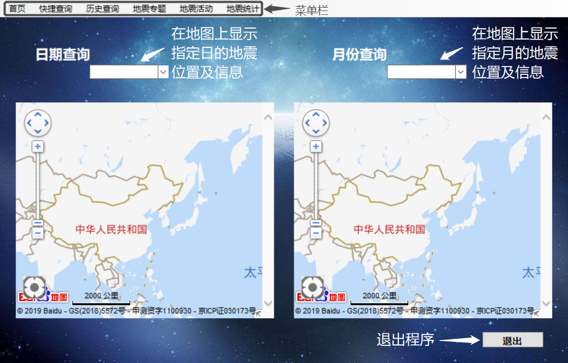

### 4.6.1菜单栏

**代码：**

private void 首页ToolStripMenuItem_Click(object sender, EventArgs e)

{

DialogResult = DialogResult.Cancel;

this.Hide();

Form0 f0 = new Form0();

f0.ShowDialog();

if (f0.DialogResult == DialogResult.Cancel)

this.Close();

}

private void 快捷查询ToolStripMenuItem_Click(object sender, EventArgs e)

{

DialogResult = DialogResult.Cancel;

this.Hide();

Form2 f2 = new Form2();

f2.ShowDialog();

if (f2.DialogResult == DialogResult.Cancel)

this.Close();

}

private void 历史查询ToolStripMenuItem_Click(object sender, EventArgs e)

{

DialogResult = DialogResult.Cancel;

this.Hide();

Form1 f1 = new Form1();

f1.ShowDialog();

if (f1.DialogResult == DialogResult.Cancel)

this.Close();

}

private void 地震专题ToolStripMenuItem_Click(object sender, EventArgs e)

{

DialogResult = DialogResult.Cancel;

this.Hide();

Form6 f6 = new Form6();

f6.ShowDialog();

if (f6.DialogResult == DialogResult.Cancel)

this.Close();

}

private void 地震统计ToolStripMenuItem_Click(object sender, EventArgs e)

{

DialogResult = DialogResult.Cancel;

this.Hide();

Form5 f5 = new Form5();

f5.ShowDialog();

if (f5.DialogResult == DialogResult.Cancel)

this.Close();

}

private void Form4_FormClosed(object sender, FormClosedEventArgs e)

{

DialogResult = DialogResult.Cancel;

}

### 4.6.2按指定日期显示地震位置

**代码：**

static string earthquake = "Data Source=.;Initial Catalog=earthquake;Integrated Security=True";

private void Form4_Load(object sender, EventArgs e)

{

string str_url = Application.StartupPath + @"\form4.html";

Uri url = new Uri(str_url);

webBrowser1.Url = url;

webBrowser1.ObjectForScripting = this;

//加载逆解析地址的html

webBrowser1.Navigate(Application.StartupPath + @"\form4.html");

//屏蔽webBrowser浏览器右键菜单

webBrowser1.IsWebBrowserContextMenuEnabled = false;

//修改webbrowser的属性使c#可以调用js方法：

webBrowser1.ObjectForScripting = this;

//

string str_ur2 = Application.StartupPath + @"\form4.html";

Uri ur2 = new Uri(str_ur2);

webBrowser2.Url = ur2;

webBrowser2.ObjectForScripting = this;

//加载逆解析地址的html

webBrowser2.Navigate(Application.StartupPath + @"\form4.html");

//屏蔽webBrowser浏览器右键菜单

webBrowser2.IsWebBrowserContextMenuEnabled = false;

//修改webbrowser的属性使c#可以调用js方法：

webBrowser2.ObjectForScripting = this;

}

private void addpoint(double jingdu, double weidu, string xinxi)

{

object[] objects1 = new object[3];

objects1[0] = jingdu;

objects1[1] = weidu;

objects1[2] = xinxi;

//传值给html中的mapInit函数

webBrowser1.Document.InvokeScript("addmarkerinfo", objects1);

}

private void dateTimePicker1_ValueChanged(object sender, EventArgs e)

{

textBox2.Text = dateTimePicker1.Value.Year.ToString() + "年" + dateTimePicker1.Value.Month.ToString() + "月" + dateTimePicker1.Value.Day.ToString() + "日";

webBrowser1.Document.InvokeScript("ClearAllMarkers");

SqlConnection mycon = new SqlConnection(earthquake);

string search = "select F1 as 时间,F2 as 震级,F3 as 纬度,F4 as 经度,F5 as 震源深度,F6 as 参考位置 from Table1$ where F1 like '%" + dateTimePicker1.Value.ToString("yyyy-MM-dd") + "%'";

SqlDataAdapter myadapter1 = new SqlDataAdapter(search, mycon);

DataSet mydataset = new DataSet();

myadapter1.Fill(mydataset, "search");

double[] arraywei = new double[mydataset.Tables["search"].Rows.Count];

for (int i = 0; i < mydataset.Tables["search"].Rows.Count; i++)

{

DataRow datar = mydataset.Tables["search"].Rows[i];

arraywei[i] = Convert.ToDouble(datar["纬度"]);

}

double[] arrayjing = new double[mydataset.Tables["search"].Rows.Count];

for (int i = 0; i < mydataset.Tables["search"].Rows.Count; i++)

{

DataRow datar = mydataset.Tables["search"].Rows[i];

arrayjing[i] = Convert.ToDouble(datar["经度"]);

//listBox2.Items.Add(arrayjing[i]);

}

string[] arrayxin = new string[mydataset.Tables["search"].Rows.Count];

for (int i = 0; i < mydataset.Tables["search"].Rows.Count; i++)

{

DataRow datar = mydataset.Tables["search"].Rows[i];

arrayxin[i] = "震级大小：" + Convert.ToString(datar["震级"]) + ";发生地点：" + Convert.ToString(datar["参考位置"]) +

";发生时间:" + Convert.ToString(datar["时间"]) + ";经纬度:" + Convert.ToString(datar["经度"]) + "，" + Convert.ToString(datar["纬度"]);

}

for (int j = 0; j < mydataset.Tables["search"].Rows.Count; j++)

{

addpoint(arrayjing[j], arraywei[j],arrayxin[j]);

}

}

### 4.6.3按指定月份显示地震位置

**代码：**

private void addpoint2(double jingdu, double weidu, string xinxi)

{

object[] objects1 = new object[3];

objects1[0] = jingdu;

objects1[1] = weidu;

objects1[2] = xinxi;

//传值给html中的mapInit函数

webBrowser2.Document.InvokeScript("addmarkerinfo", objects1);

}

private void dateTimePicker2_ValueChanged(object sender, EventArgs e)

{

textBox1.Text = dateTimePicker2.Value.Year.ToString() + " 年 " + dateTimePicker2.Value.Month.ToString() + " 月 ";

webBrowser2.Document.InvokeScript("ClearAllMarkers");

SqlConnection mycon = new SqlConnection(earthquake);

string search = "select F1 as 时间,F2 as 震级,F3 as 纬度,F4 as 经度,F5 as 震源深度,F6 as 参考位置 from Table1$ where F1 like '%" + dateTimePicker2.Value.ToString("yyyy-MM") + "%'";

SqlDataAdapter myadapter2 = new SqlDataAdapter(search, mycon);

DataSet mydataset2 = new DataSet();

myadapter2.Fill(mydataset2, "search");

double[] arraywei2 = new double[mydataset2.Tables["search"].Rows.Count];

for (int i = 0; i < mydataset2.Tables["search"].Rows.Count; i++)

{

DataRow datar = mydataset2.Tables["search"].Rows[i];

arraywei2[i] = Convert.ToDouble(datar["纬度"]);

}

double[] arrayjing2 = new double[mydataset2.Tables["search"].Rows.Count];

for (int i = 0; i < mydataset2.Tables["search"].Rows.Count; i++)

{

DataRow datar = mydataset2.Tables["search"].Rows[i];

arrayjing2[i] = Convert.ToDouble(datar["经度"]);

//listBox2.Items.Add(arrayjing[i]);

}

string[] arrayxin2 = new string[mydataset2.Tables["search"].Rows.Count];

for (int i = 0; i < mydataset2.Tables["search"].Rows.Count; i++)

{

DataRow datar = mydataset2.Tables["search"].Rows[i];

arrayxin2[i] = "震级大小：" + Convert.ToString(datar["震级"]) + ";发生地点：" + Convert.ToString(datar["参考位置"]) +

";发生时间:" + Convert.ToString(datar["时间"]) + ";经纬度:" + Convert.ToString(datar["经度"]) + "，" + Convert.ToString(datar["纬度"]);

}

for (int j = 0; j < mydataset2.Tables["search"].Rows.Count; j++)

{

addpoint2(arrayjing2[j], arraywei2[j], arrayxin2[j]);

}

}

### 4.6.4退出程序

**代码：**

private void button1_Click(object sender, EventArgs e)

{

this.Close();

}

### 注4.7.2和4.7.3都需要用到JavaScript代码

<!DOCTYPE html>

<html>

<head>

<meta http-equiv="Content-Type" content="text/html; charset=utf-8" />

<meta name="viewport" content="initial-scale=1.0, user-scalable=no" />

<style type="text/css">

body, html {width: 100%;height: 100%;margin:0;font-family:"微软雅黑";}

#allmap{width:100%;height:100%;}

p{margin-left:5px; font-size:14px;}

</style>

<script type="text/javascript" src="http://api.map.baidu.com/api?v=2.0&ak=5H81a8zEwctwf081w60uwCbt0ZktgwL2"></script>

<title>form4</title>

</head>

<body>

<div id="allmap"></div>

<div id="lng" style="display:none"></div>

<div id="lat" style="display:none"></div>

</body>

</html>

<script type="text/javascript">

var map = new BMap.Map("allmap");

map.centerAndZoom(new BMap.Point(116.404, 39.915), 2);

map.addControl(new BMap.ScaleControl()); //添加相关控件

map.addControl(new BMap.OverviewMapControl());//添加相关控件

var ctrl_nav = new BMap.NavigationControl({ anchor: BMAP_ANCHOR_TOP_LEFT, type: BMAP_NAVIGATION_CONTROL_LARGE });

map.addControl(ctrl_nav); //添加相关控件

map.enableDragging();

map.enableScrollWheelZoom();

map.enableDoubleClickZoom();

map.enableKeyboard();

map.enableContinuousZoom();

map.enableInertialDragging();

var geolocationControl = new BMap.GeolocationControl();

geolocationControl.addEventListener("locationSuccess", function(e){

// 定位成功事件

var address = '';

address += e.addressComponent.province;

address += e.addressComponent.city;

address += e.addressComponent.district;

address += e.addressComponent.street;

address += e.addressComponent.streetNumber;

alert("当前定位地址为：" + address);

});

geolocationControl.addEventListener("locationError",function(e){

// 定位失败事件

alert(e.message);

});

map.addControl(geolocationControl);

function openGetDistance() {

var myDis=new BMapLib.DistanceTool(map);//mapΪɏæґ¾­³õʼ»¯ºõĵ؍¼ʵÀý

myDis.open();

}

function myTimer(JinDu, WeiDu, str)

{

var BaiDuPoint = new BMap.Point(JinDu, WeiDu);

map.centerAndZoom(BaiDuPoint, 17);

var marker = new BMap.Marker(BaiDuPoint);

map.addOverlay(marker);

//map.openInfoWindow(infoWindow, BaiDuPoint);

//map.setCenter(BaiDuPoint); //Ҕµ±ǰµėø±굣Ϊ֐Єϔʾ

var label = new BMap.Label(str,{offset:new BMap.Size(20,-10)});

marker.setLabel(label);

}

function addmarkerinfo(jingdu,weidu,wenzi)

{

var point = new BMap.Point(jingdu , weidu);

var marker = new BMap.Marker(point); // 创建标注

var content = wenzi;

map.addOverlay(marker); // 将标注添加到地图中

addClickHandler(content,marker);

}

function addClickHandler(content,marker){

marker.addEventListener("click",function(e){

openInfo(content,e)}

);

}

function openInfo(content,e){

var p = e.target;

var opts = {

width : 250, // 信息窗口宽度

height: 100, // 信息窗口高度

title : "信息窗口" , // 信息窗口标题

enableMessage:true//设置允许信息窗发送短息

};

var point = new BMap.Point(p.getPosition().lng, p.getPosition().lat);

var infoWindow = new BMap.InfoWindow(content,opts); // 创建信息窗口对象

map.openInfoWindow(infoWindow,point); //开启信息窗口

}

function getlocation()

{var geolocation = new BMap.Geolocation();

geolocation.getCurrentPosition(function(r){

if(this.getStatus() == BMAP_STATUS_SUCCESS){

var mk = new BMap.Marker(r.point);

map.addOverlay(mk);

map.panTo(r.point);

alert('您的位置：'+r.point.lng+','+r.point.lat);

document.getElementById("lng").innerText = r.point.lng;

document.getElementById("lat").innerText = r.point.lat;

lnginfo=r.point.lng.toString();

latinfo=r.point.lat.toString();

window.external.Lnginfo(lnginfo);

window.external.Latinfo(latinfo);

}

else {

alert('failed'+this.getStatus());

}

},{enableHighAccuracy: true})

}

function findemergency(x1,y1,x2,y2){

var p1 = new BMap.Point(x1,y1);

var p2 = new BMap.Point(x2,y2);

var walking = new BMap.WalkingRoute(map, {renderOptions: {map: map, panel: "r-result", autoViewport: true}});

walking.search(p1, p2);

}

</script>

4.7地震统计

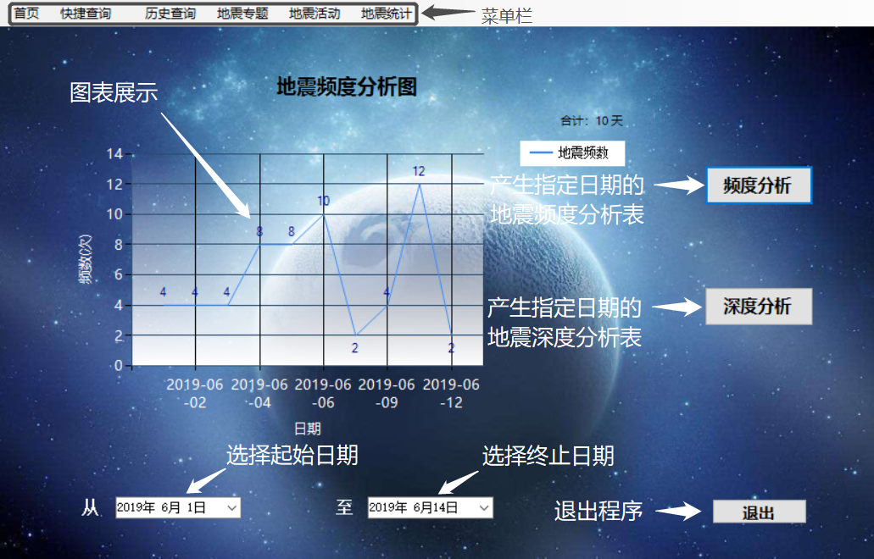

### 4.7.1菜单栏

private void Form5_FormClosed(object sender, FormClosedEventArgs e)

{

DialogResult = DialogResult.Cancel;

}

private void 首页ToolStripMenuItem_Click(object sender, EventArgs e)

{

DialogResult = DialogResult.Cancel;

this.Hide();

Form0 f0 = new Form0();

f0.ShowDialog();

if (f0.DialogResult == DialogResult.Cancel)

this.Close();

}

private void 历史查询ToolStripMenuItem_Click(object sender, EventArgs e)

{

DialogResult = DialogResult.Cancel;

this.Hide();

Form1 f1 = new Form1();

f1.ShowDialog();

if (f1.DialogResult == DialogResult.Cancel)

this.Close();

}

private void 快捷查询ToolStripMenuItem_Click(object sender, EventArgs e)

{

DialogResult = DialogResult.Cancel;

this.Hide();

Form2 f2 = new Form2();

f2.ShowDialog();

if (f2.DialogResult == DialogResult.Cancel)

this.Close();

}

private void 地震专题ToolStripMenuItem_Click(object sender, EventArgs e)

{

DialogResult = DialogResult.Cancel;

this.Hide();

Form6 f6 = new Form6();

f6.ShowDialog();

if (f6.DialogResult == DialogResult.Cancel)

this.Close();

}

private void 地震活动ToolStripMenuItem_Click(object sender, EventArgs e)

{

DialogResult = DialogResult.Cancel;

this.Hide();

Form4 f4 = new Form4();

f4.ShowDialog();

if (f4.DialogResult == DialogResult.Cancel)

this.Close();

}

### 4.7.2地震频度分析表

**代码：**

private void Form5_Load(object sender, EventArgs e)

{

Chart1.Legends.Add(legend2);

}

Legend legend2 = new Legend();

static string earthquake = "Data Source=.;Initial Catalog=earthquake;Integrated Security=True";

private void button1_Click(object sender, EventArgs e)

{

SqlConnection mycon = new SqlConnection(earthquake);

string search1 = "select left(F1,10) as 日期,count(F6) as 发生次数 from Table1$ where F1>= " +"'" + dateTimePicker1.Value.ToString("yyyy-MM-dd")+ "'"+"AND F1<= " +"'" +dateTimePicker2.Value.ToString("yyyy-MM-dd ")+"' group by left(F1,10)";

SqlDataAdapter myadapter1 = new SqlDataAdapter(search1, mycon);

DataTable mytable1 = new DataTable();

DataTable mytable2 = new DataTable();

myadapter1.Fill(mytable1); myadapter1.Fill(mytable2);

if (mytable1.Rows.Count > 900)

{

string search2 = "select left(F1,4) as 日期,count(F6) as 发生次数 from Table1$ where F1>= " + "'" + dateTimePicker1.Value.ToString("yyyy-MM-dd") + "'" + "AND F1<= " + "'" + dateTimePicker2.Value.ToString("yyyy-MM-dd ") + "' group by left(F1,4)";

SqlDataAdapter myadapter2 = new SqlDataAdapter(search2, mycon);

mytable1.Clear();

myadapter2.Fill(mytable1);

}

else if (mytable1.Rows.Count > 15)

{

string search2 = "select left(F1,7) as 日期,count(F6) as 发生次数 from Table1$ where F1>= " + "'" + dateTimePicker1.Value.ToString("yyyy-MM-dd") + "'" + "AND F1<= " + "'" + dateTimePicker2.Value.ToString("yyyy-MM-dd ") + "' group by left(F1,7)";

SqlDataAdapter myadapter2 = new SqlDataAdapter(search2, mycon);

mytable1.Clear();

myadapter2.Fill(mytable1);

}

Chart1.Series.Clear();

Chart1.Series.Add("地震频数");

Chart1.DataSource = mytable1;

Chart1.Series["地震频数"].XValueMember = "日期";

Chart1.Series["地震频数"].YValueMembers = "发生次数";

Chart1.Titles.Clear();

Chart1.Titles.Add("地震频度分析图");

Chart1.Titles[0].ForeColor = Color.Black;

Chart1.Titles[0].Font = new Font("微软雅黑", 14f, FontStyle.Bold);

Chart1.Titles[0].Alignment = ContentAlignment.TopCenter;

Chart1.Titles.Add("合计："+mytable2.Rows.Count.ToString()+" 天");

Chart1.Titles[1].ForeColor = Color.Black;

Chart1.Titles[1].Font = new Font("微软雅黑", 8f, FontStyle.Regular);

Chart1.Titles[1].Alignment = ContentAlignment.TopRight;

//控件背景

Chart1.BackColor = Color.Transparent;

//图表区背景

Chart1.ChartAreas[0].BackColor = Color.Transparent;

Chart1.ChartAreas[0].BorderColor = Color.Transparent;

//X坐标轴颜色

Chart1.ChartAreas[0].AxisX.LineColor = ColorTranslator.FromHtml("#38587a"); ;

Chart1.ChartAreas[0].AxisX.LabelStyle.ForeColor = Color.White;

Chart1.ChartAreas[0].AxisX.LabelStyle.Font = new Font("微软雅黑", 10f, FontStyle.Regular);

//X坐标轴标题

Chart1.ChartAreas[0].AxisX.Title = "日期";

Chart1.ChartAreas[0].AxisX.TitleFont = new Font("微软雅黑", 10f, FontStyle.Regular);

Chart1.ChartAreas[0].AxisX.TitleForeColor = Color.White;

Chart1.ChartAreas[0].AxisX.TextOrientation = TextOrientation.Horizontal;

Chart1.ChartAreas[0].AxisX.ToolTip = "日期";

if (mytable1.Rows.Count < 10)

{

//X轴标签间距

Chart1.ChartAreas[0].AxisX.Interval = 1;

Chart1.ChartAreas[0].AxisX.LabelStyle.IsStaggered = true;

Chart1.ChartAreas[0].AxisX.LabelStyle.Angle = -45;

Chart1.ChartAreas[0].AxisX.TitleFont = new Font("微软雅黑", 14f, FontStyle.Regular);

Chart1.ChartAreas[0].AxisX.TitleForeColor = Color.White;

//X轴网络线条

Chart1.ChartAreas[0].AxisX.MajorGrid.Enabled = true;

Chart1.ChartAreas[0].AxisX.MajorGrid.LineColor = ColorTranslator.FromHtml("#2c4c6d");

}

//Y坐标轴颜色

Chart1.ChartAreas[0].AxisY.LineColor = ColorTranslator.FromHtml("#38587a");

Chart1.ChartAreas[0].AxisY.LabelStyle.ForeColor = Color.White;

Chart1.ChartAreas[0].AxisY.LabelStyle.Font = new Font("微软雅黑", 10f, FontStyle.Regular);

//Y坐标轴标题

Chart1.ChartAreas[0].AxisY.Title = "频数(次)";

Chart1.ChartAreas[0].AxisY.TitleFont = new Font("微软雅黑", 10f, FontStyle.Regular);

Chart1.ChartAreas[0].AxisY.TitleForeColor = Color.White;

Chart1.ChartAreas[0].AxisY.TextOrientation = TextOrientation.Rotated270;

Chart1.ChartAreas[0].AxisY.ToolTip = "频数(次)";

//Y轴网格线条

Chart1.ChartAreas[0].AxisY.MajorGrid.Enabled = true;

Chart1.ChartAreas[0].AxisY.MajorGrid.LineColor = ColorTranslator.FromHtml("#2c4c6d");

Chart1.ChartAreas[0].AxisY2.LineColor = Color.Transparent;

Chart1.ChartAreas[0].BackGradientStyle = GradientStyle.TopBottom;

Legend legend = new Legend("legend");

legend.Title = "legendTitle";

Chart1.Series["地震频数"].XValueType = ChartValueType.String; //设置X轴上的值类型

Chart1.Series["地震频数"].Label = "#VAL"; //设置显示X Y的值

Chart1.Series["地震频数"].LabelForeColor = Color.DarkBlue;

Chart1.Series["地震频数"].ToolTip = "#VALX:#VAL(次)"; //鼠标移动到对应点显示数值

Chart1.Series["地震频数"].ChartType = SeriesChartType.Line; //图类型(折线)

}

### 4.7.3地震深度分析表

**代码：**

private void button2_Click(object sender, EventArgs e)

{

SqlConnection mycon2 = new SqlConnection(earthquake);

string search2 = "select count(case when F5<60 then F5 end) as 浅源地震,count(case when F5<300 and F5>60 then F5 end) as 中源地震,count(case when F5>300 then F5 end) as 深源地震 from Table1$ where F1>= '" + dateTimePicker1.Value.ToString("yyyy-MM-dd") + "' AND F1<= " + "'" + dateTimePicker2.Value.ToString("yyyy-MM-dd ") + "'";

SqlDataAdapter myadapter2 = new SqlDataAdapter(search2, mycon2);

DataTable mytable2 = new DataTable();

myadapter2.Fill(mytable2);

string[] x={"浅源地震","中源地震","深源地震"};

double[] y=new double[3];

if (mytable2.Rows.Count==0)

{

MessageBox.Show("出错！");

}

else

{

for (int i = 0; i < 3; i++)

{

y[i] = Convert.ToDouble(mytable2.Rows[0].ItemArray[i]);

}

}

Chart1.Series.Clear(); Chart1.Titles.Clear();

Chart1.Series.Add("Series1");

Chart1.Titles.Add("震源深度分析表");

Chart1.Titles[0].ForeColor = Color.Black;

Chart1.Titles[0].Font = new Font("微软雅黑", 14f, FontStyle.Bold);

Chart1.Titles[0].Alignment = ContentAlignment.TopCenter;

Chart1.Titles.Add("合计："+(y.Sum()).ToString()+"次");

Chart1.Titles[1].ForeColor = Color.Black;

Chart1.Titles[1].Font = new Font("微软雅黑", 8f, FontStyle.Regular);

Chart1.Titles[1].Alignment = ContentAlignment.TopRight;

//控件背景

Chart1.BackColor = Color.Transparent;

//图表区背景

Chart1.ChartAreas[0].BackColor = Color.Transparent;

Chart1.ChartAreas[0].BorderColor = Color.Transparent;

//背景渐变

Chart1.ChartAreas[0].BackGradientStyle = GradientStyle.None;

//图例样式

Legend legend2 = new Legend();

legend2.Title = "图例";

legend2.TitleBackColor = Color.Transparent;

legend2.BackColor = Color.Transparent;

legend2.TitleForeColor = Color.Pink;

legend2.TitleFont = new Font("微软雅黑", 10f, FontStyle.Regular);

legend2.Font = new Font("微软雅黑", 8f, FontStyle.Regular);

legend2.ForeColor = Color.Pink;

Chart1.Series["Series1"].XValueType = ChartValueType.String; //设置X轴上的值类型

Chart1.Series["Series1"].Label = "#VAL"; //设置显示X Y的值

Chart1.Series["Series1"].LabelForeColor = Color.White;

Chart1.Series["Series1"].ToolTip = "#VALX:#VAL(次)"; //鼠标移动到对应点显示数值

Chart1.Series["Series1"].ChartType = SeriesChartType.Pie; //图类型(折线)

Chart1.Series["Series1"].Color = Color.Lime;

Chart1.Series["Series1"].LegendText = legend2.Name;

Chart1.Series["Series1"].IsValueShownAsLabel = true;

Chart1.Series["Series1"].LabelForeColor = Color.Black;

Chart1.Series["Series1"].CustomProperties = "DrawingStyle = Cylinder";

Chart1.Series["Series1"].CustomProperties = "PieLabelStyle = Outside";

Chart1.Legends[0].Position.Auto = true;

Chart1.Series["Series1"].IsValueShownAsLabel = true;

//是否显示图例

Chart1.Series["Series1"].IsVisibleInLegend = true;

Chart1.Series["Series1"].ShadowOffset = 0;

//饼图折线

Chart1.Series["Series1"]["PieLineColor"] = "Black";

//绑定数据

Chart1.Series["Series1"].Points.DataBindXY(x, y);

Chart1.Series["Series1"].Points[0].Color = Color.Pink;

//绑定颜色

Chart1.Series["Series1"].Palette = ChartColorPalette.BrightPastel;

}

### 4.7.4退出

**代码：**

private void button3_Click(object sender, EventArgs e)

{

this.Close();

}

注意：系统自动生成的代码不要列出来。

# 五．系统测试

5.1登陆及注册界面

### 5.1.1登陆

#### 成功：

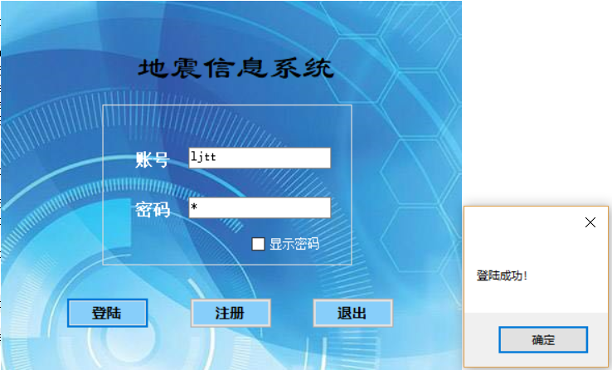

#### 失败：

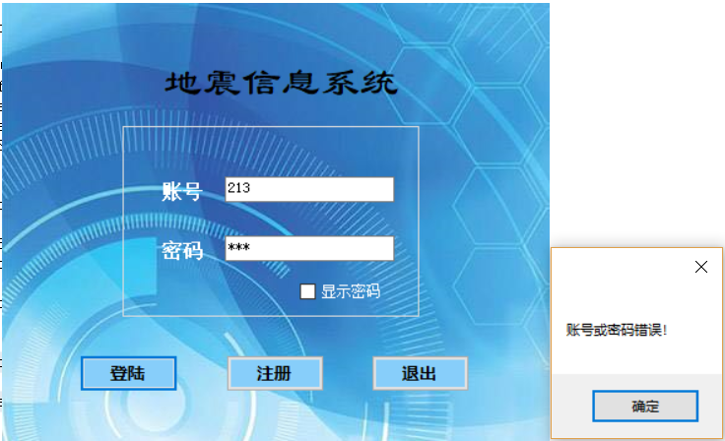

### 5.1.2注册

#### 成功：

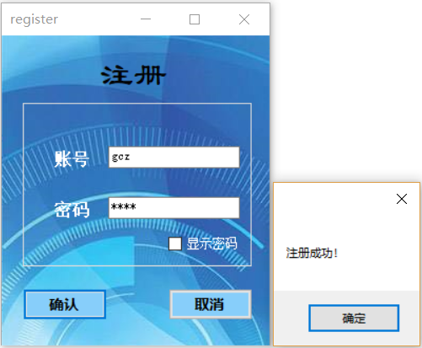

#### 失败：

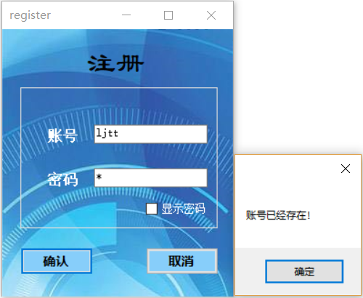

5.2首页

### 5.2.1最近地震显示

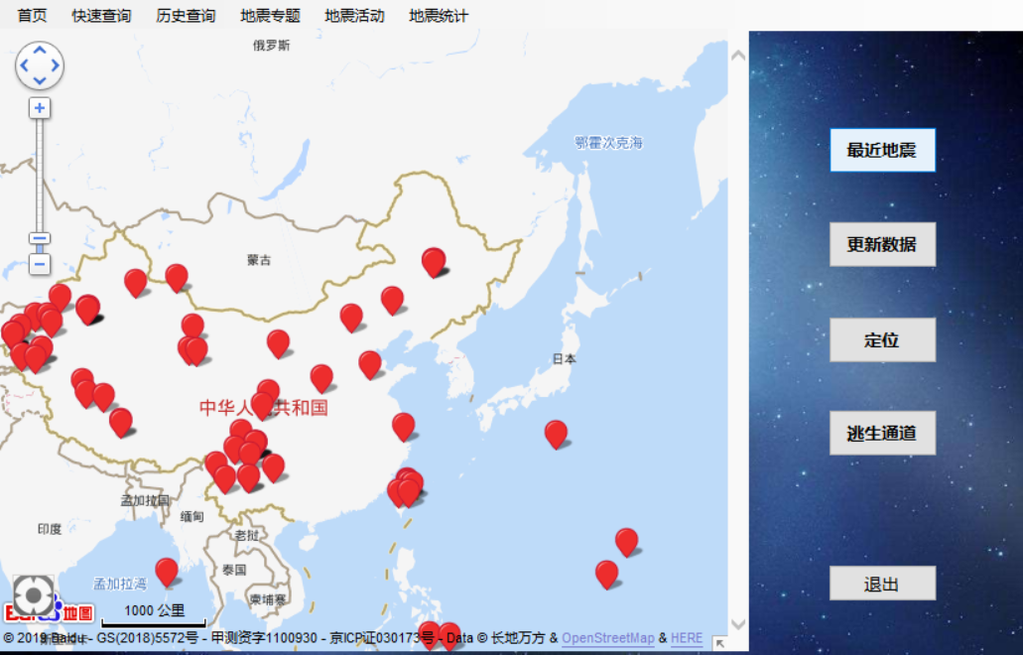

### 5.2.2更新数据

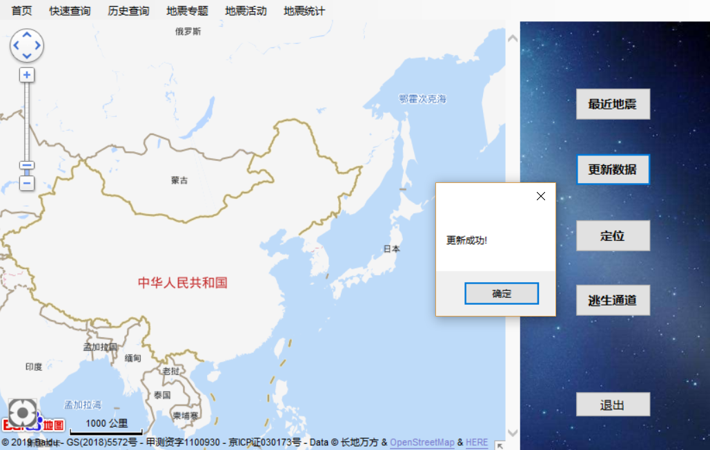

### 5.2.3定位

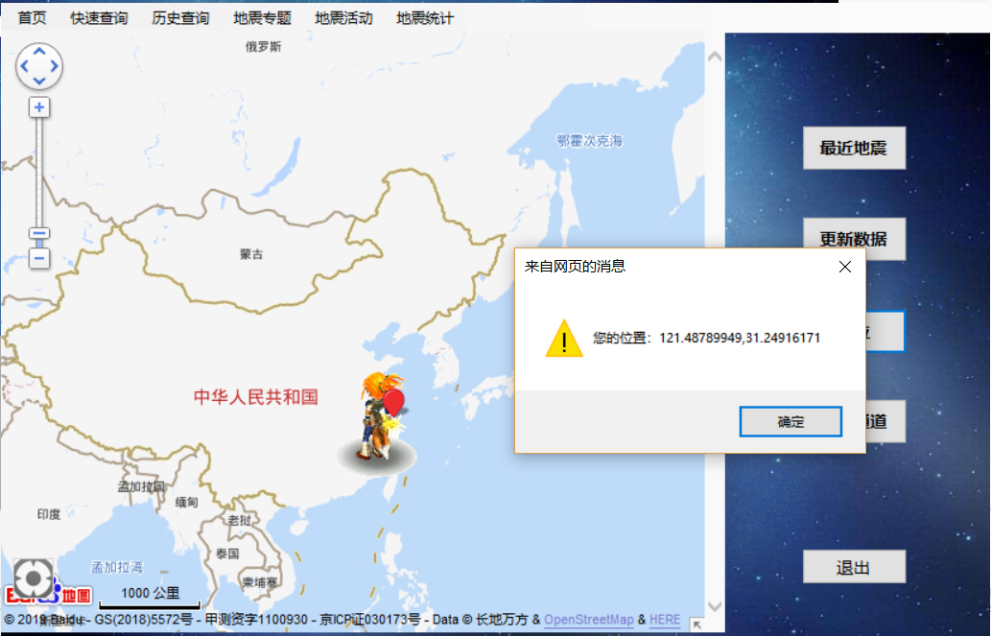

### 5.2.4逃生通道

#### 情形一：无危险，可放心

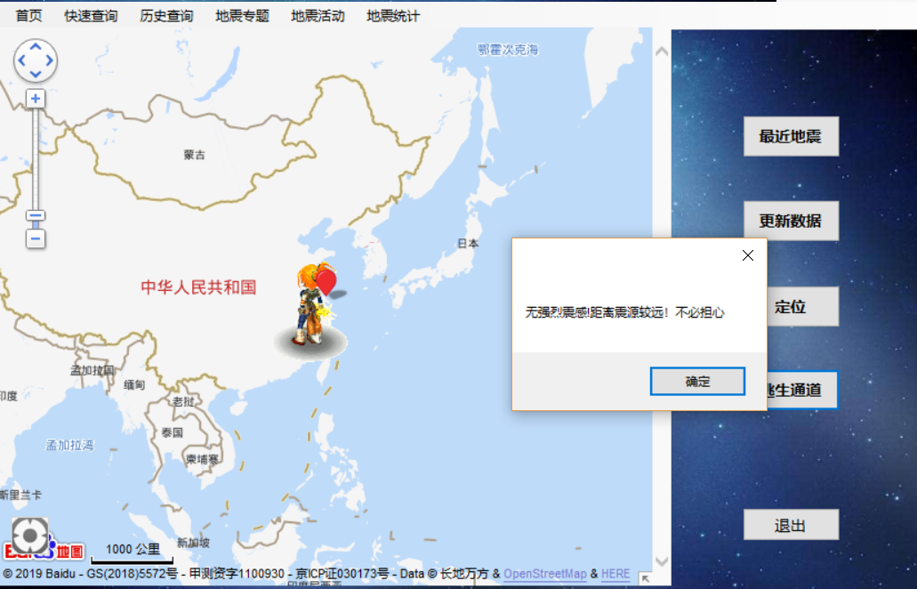

#### 情形二：有危险，需避难。

**Step1**

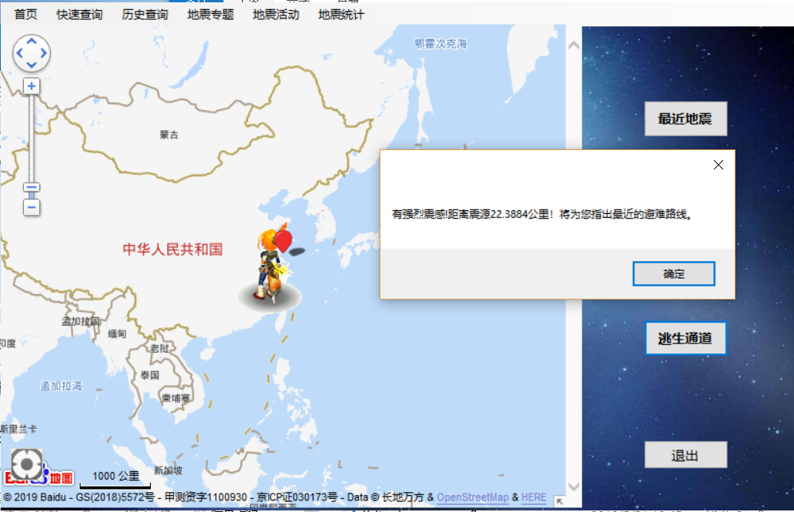

**Step2**

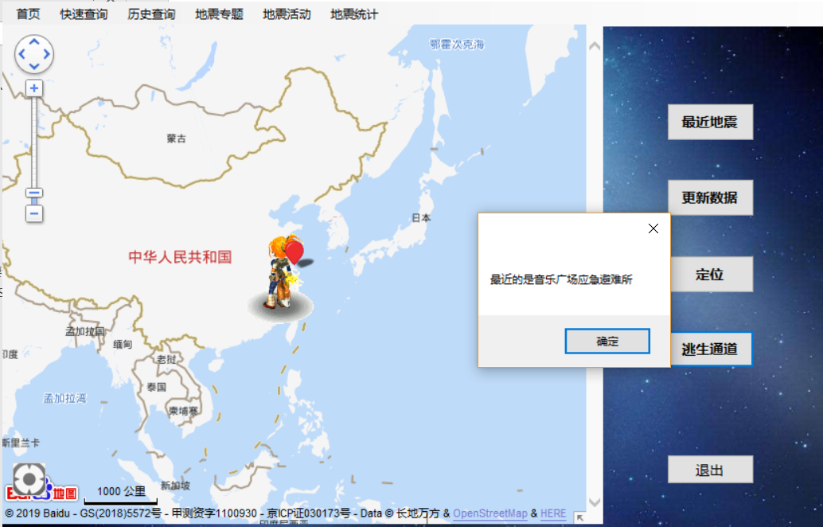

**Step3**

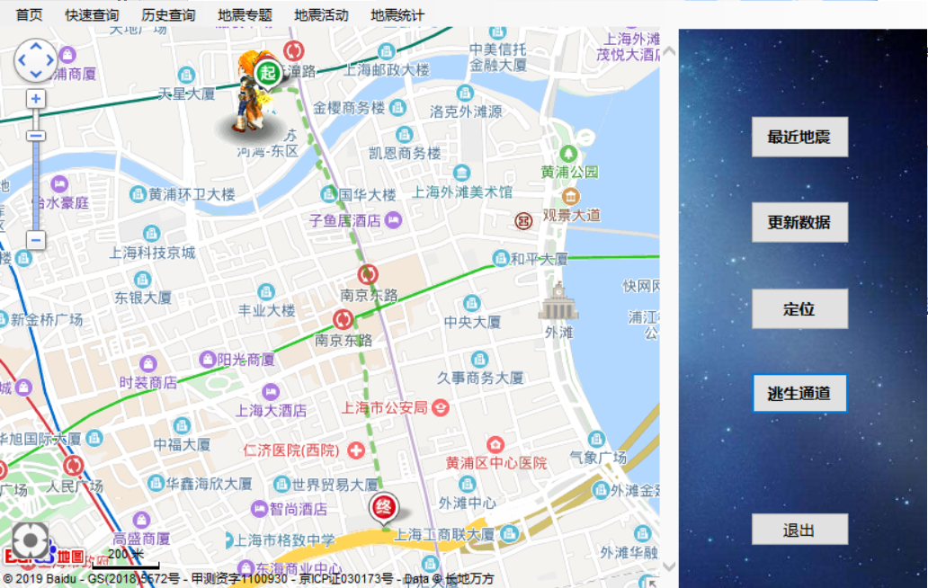

5.3快捷查询

### 5.3.1查询

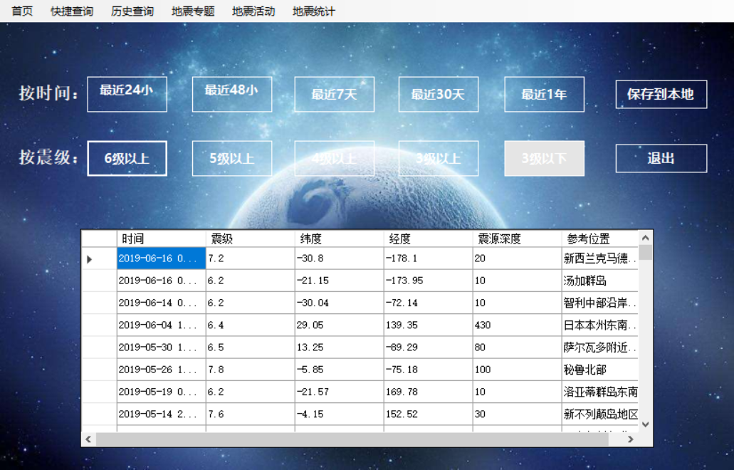

### 5.3.2保存到本地

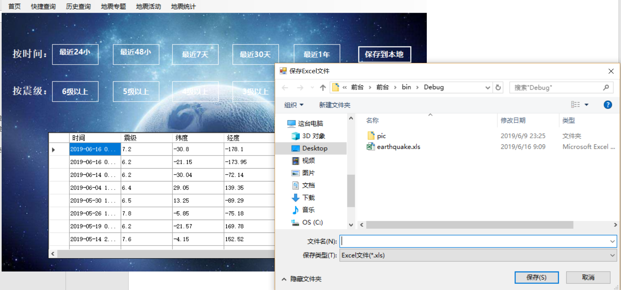

5.4历史查询

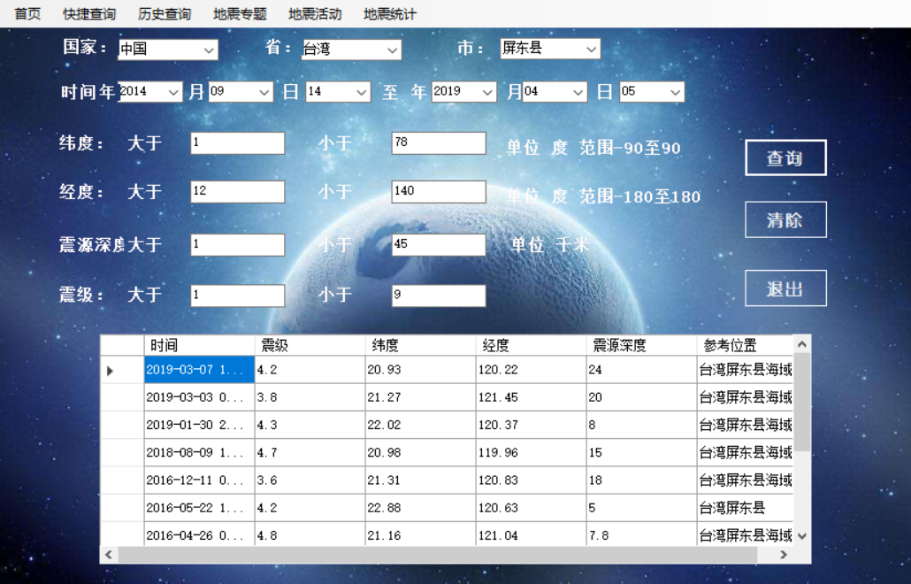

5.5地震专题

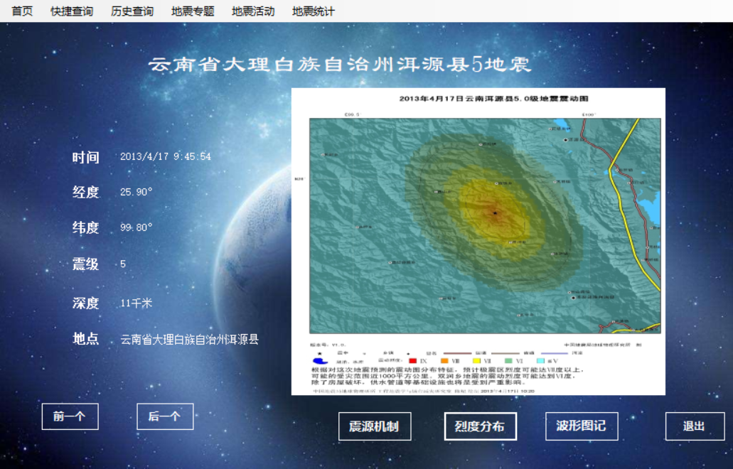

5.6地震活动

### 5.6.1查询每日

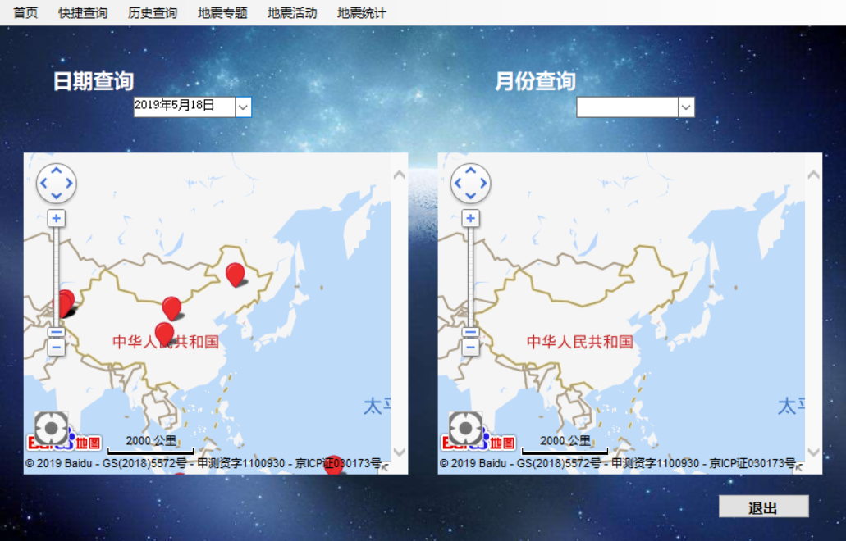 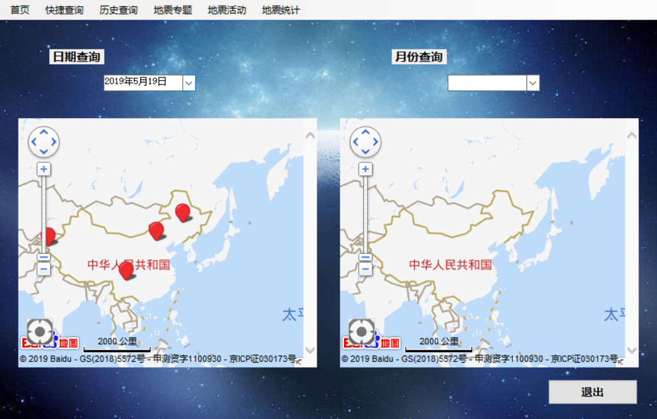

### 5.6.2查询每月

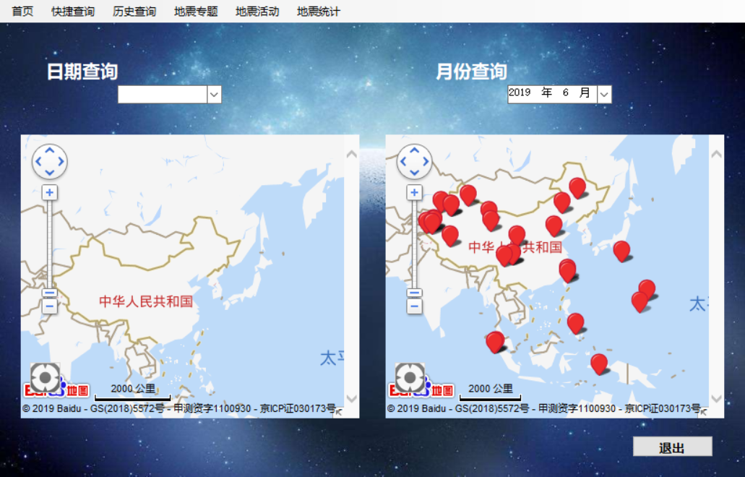 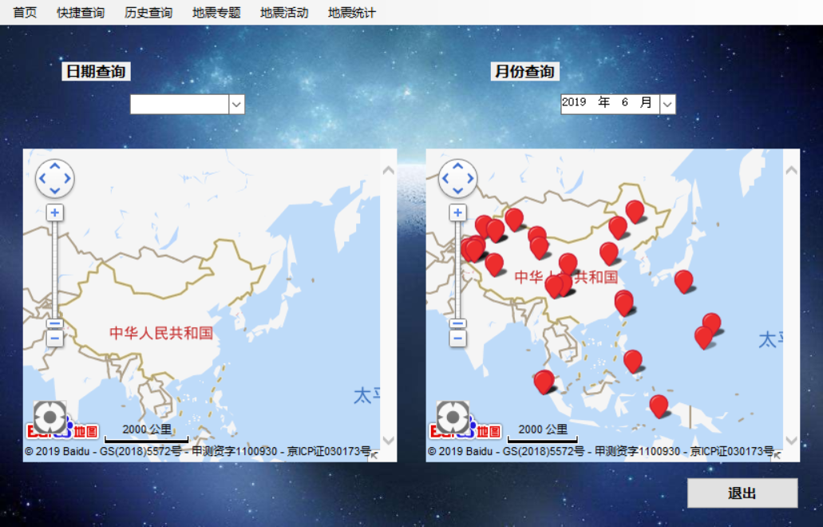

5.7地震统计

### 5.7.1地震频度分析

#### 按天数

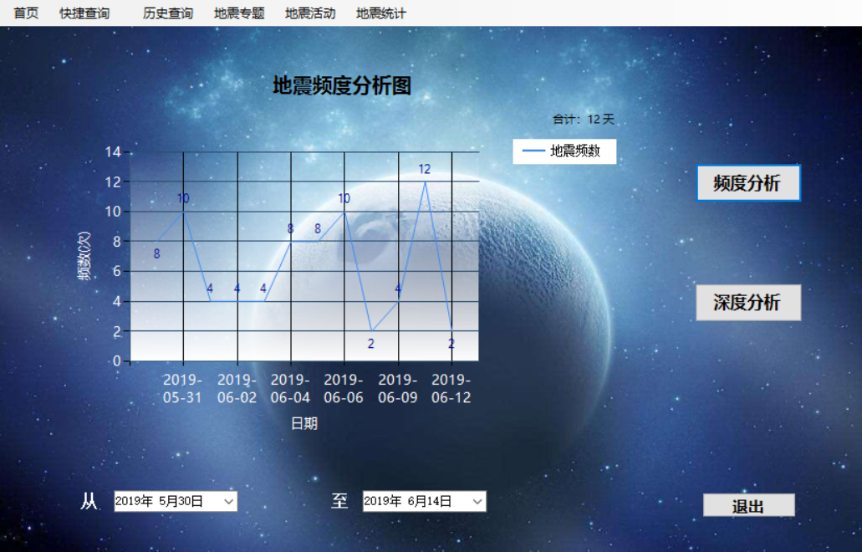

#### 按月份

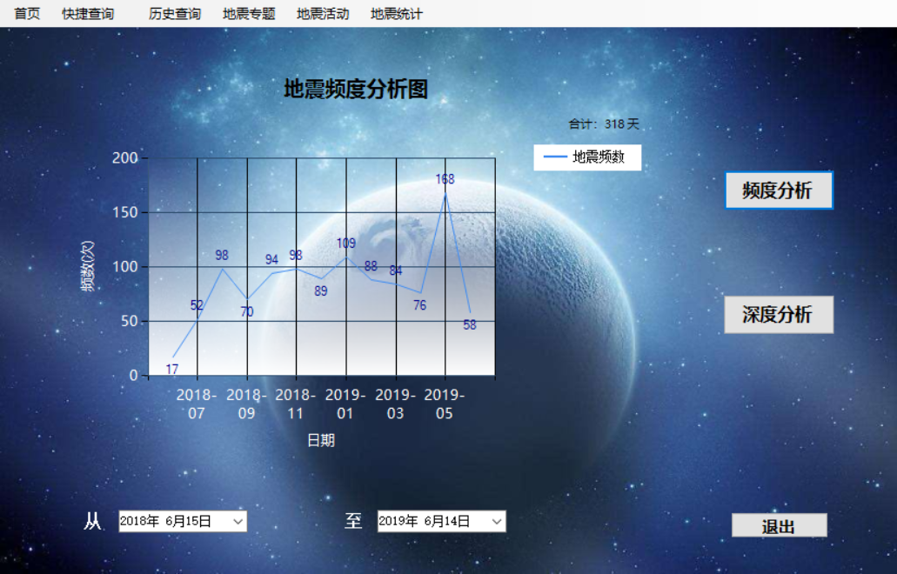

#### 按年份

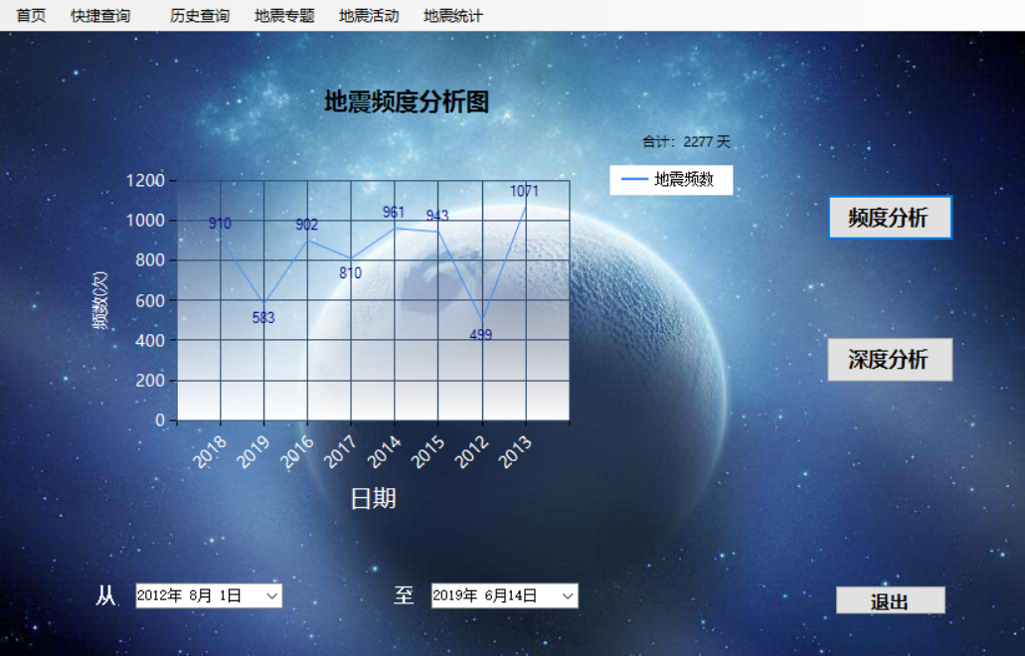

### 5.7.2地震深度分析

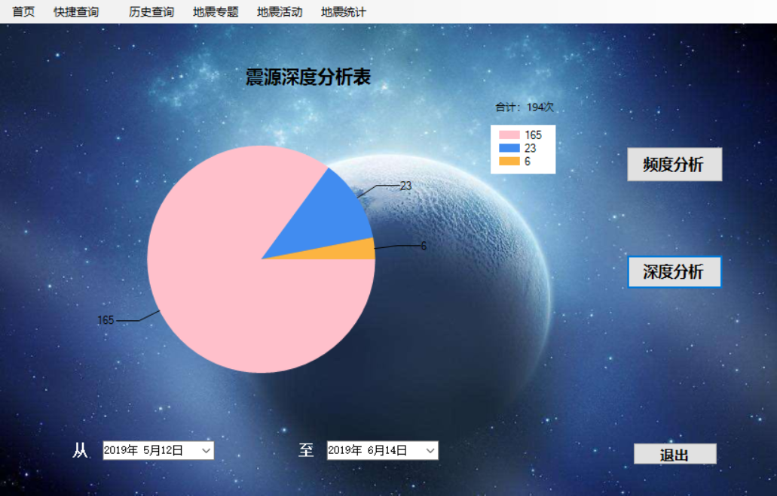

# 六．自我评述

利剑韬

这次大作业让我发现了自己很多不足的地方。首先是自己很多程序写得不够人性化，在做完之后对比了很多其他软件我才发现，我的软件其实做得只是差强人意，但没有为客户端体验着想。其次是代码不够严谨，我很多地方会出现如果客户故意刁难就会bug的情况，虽然绝大多数情况都可以正常运行，但一旦出错很可能出现死机。这两点让我感受到了软件开发的不易，也让我深刻认识到了人机界面设计有多么重要。

任泽琦

在最后这个大作业项目中，我主要参与了快捷查询，历史查询这两个功能的建立、界面按钮的美化以及国家省市地区数据库的建立和上海市应急避难场所的搜集，可能和两个队友相比，参与的工作没有那么高端，主要是以C#和SQL Server为主，进一步加深掌握后台数据库的建立，数据的输入和前台界面设计美化以及前后台之间的联系。但是其中也还有一些问题需要解决，需要更加人性化，面向对象的程序就需要多为用户考虑，期待能做的更完美。

高程展

本项目中比较创新的一点是大量的与python和网页做交互，用到了很多课外知识，达到了很多像是实时更新数据，实时提供逃生路线，并能借助百度地图可视化地显示数据这些效果。也用到了一些基本的所学知识，比如画表格，查询数据，回填数据等一些课内知识。当然还是有很多不完善的地方，比如定位的不准确性，科普功能还需完善，没有结合专业软件导致专业性结合不强，界面切换任意切换使用“用户控件”（而不是form）做更好等等。但我觉得我们做的最为欠缺的是数据库的设计过程不够好，可能是第一次做，还没有经验，一个概念模式和逻辑设计模式在一开始并不是很清晰，只是有基本的想法，而等到最后再来做这个概念模式和逻辑模式设计，在设计思路上是有问题的，以后应当注意。

# 七．课程学习体会

任泽琦

在《数据库技术》这门课程中，主要的感受是这门课还是有一定的难度的，平常也会有一定量的作业，课下也需要花费一定量的时间去复习，去思考。大作业需要的知识也很多，也很需要时间和能力。但是上这门课也收获了很多。学到了C#和SQL Server的知识，懂得了数据库开发。在最后的大作业中，通过团队合作，共同完成了最后的作品。虽然期间也遇到了很多困难，但是三个人互相帮助以及自己上网查了资料都成功解决了。之前听说这门课难，但是我觉得选这门课不后悔。

利剑韬

大作业的设计也让我学会了很多。第一就是代码，通过网络，我查到了很多编程的论坛，在这里我学到了如何爬取网站信息、如何进行窗口界面美化等等。这不仅让我的作品更加完美，也让我的学习能力得到了提高。第二就是创造力。我们在小组讨论中，不断提出了完善软件的好办法，不断提出解决问题的新思路，这大大锻炼了我们的创造力和发散思维。最后是学习能力，我们的程序最大的亮点应该在于我们除了c#之外，关联了很多其他软件的代码，比如python和java等等，连接了html和excel，这就是我们在软件制作过程中花时间自己学习的。短时间掌握一门技术的能力，不仅对这个项目，对我未来的学习发展也有很重要的意义。

高程展：

项目初期可以说是“书到用时方恨少”，一开始想做爬虫，做定位、标注，需要用到javascript和python，py虽是有些基础，但是爬虫一块还是知识盲区（还好利剑韬写出来了），JavaScript也从来没学过，所以开头非常吃力，遇到了不少困难：爬虫爬出来了，但是数据怎么传；放到excel后，C#怎么调取excel；api注册好了，但是怎么标记点位；点位会标记了，但怎么通过C#传值给他；C#能传给他，那网页的数据（坐标）怎么传回来；地震发生了，怎么在地图上显示逃生路线……还好现在来看，慢慢查资料问题都还是一个个地都攻克了，也确实学到了不少东西，以后可能遇到什么，不会不要紧，只需相信自己能很快学会。

这段时间有个体会是要学会灵活变通，不能死磕一条路。就像一开始爬数据，找到一个地震网站，试了很久总是失败，利剑韬找了另一个，发现成功了，后来发现原来是第一个网站禁掉了爬取数据的权限，对方是专业的防火墙，除非真的技术高超，否则无论如何也爬不了。还有一个是传数据，原本想python直接传给sqlsever，确实是有可能可行的，网上也有资料，但是经过多次失败后，绕道excel，再绕道C#，曲线救国，最后成功了。

小组做一个项目，也深刻体会到合作的重要性，1+1+1=3？有时候是>3,有时候是<3。当配合的好，比如一起讨论如何美化，一起设计，每个人有每个人的想法，互相听取互相学习，有思维碰撞的时候，是>3的；当三个人各做各的，互不交流，最后整合时发现互相的想法差很远，很多地方不匹配，相互的表意不明确，造成了很多时间精力的浪费，互相分工还不如一个人效率高，这时候是<3的。而这过程之中，这两种情况均有出现，以后还得好好注意和把握。

还有一个感悟是代码真的容不得半点差错。虽然有时候感觉代码真的太“抠”了，不就一个小错，调试了很久，找了很久，才终于排除它。但是后来越发觉得，代码真的很可靠，就是这样的讲逻辑，容不得半点错，才能是如此可靠。

# 分工

